高维军简历
1968年2月生于陕西省佳县。
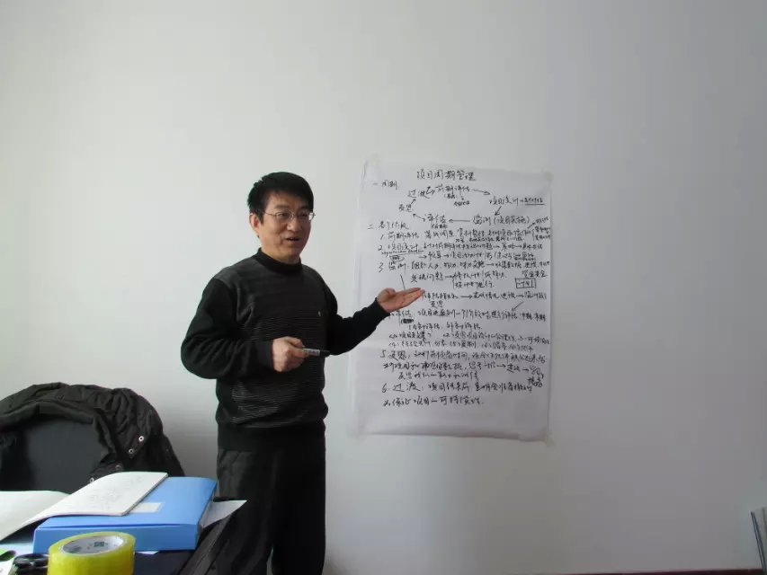
1987年7月毕业于陕西省榆林中学，同年考入西北农业大学读本科，专业是农业化学。
1991年7月由西北农业大学毕业，分配到陕西佳县农资公司工作，工作十年。当我离开时任办公室主任。
2001年加入陕西秦原生物公司，任技术员，工作2年。
2004年3月加入国际计划，任社区发展协调员，兼管健康领域，后又管理教育领域项目2年，在陕西榆林项目办工作到2010年6月底离开。
2010年7月加入儿童乐益会，做手牵手项目（幼儿园项目），任项目官员，常驻四川省井研县教育局，后来又同时管理湖南省江永县项目。
2012年2月离开儿童乐益会。
2013年1月1日加入国际美慈组织，任云南省项目统筹，于2013年12月完成了“中国乡村减灾与扶贫能力建设项目”云南项目部分。
2014年10月加入世界宣明会，任集善残疾儿童助养项目甘肃省定西项目办主任，2015年4月1日辞职。

手机号：18791825817
E-mail：yl-gwj@163.com

Resume of Gao Weijun
I was born in Jia County , Shan XI province in Feb. 1968.
I graducated from Yulin Middle School in July,1987 then into North-west Agriculture University(4year), my major is Agriculture-chemistry.
I graduated from North-west Agriculture University and was assigned to work in Jiaxian Agri-material firm. I work there ten years. I was office director when I left.
In 2001 I joined in ShanXi Qinyuan Biology Firm as technologist for 2years.
March, 2004 I joined into Yulin Unit，Plan International as CDF(community development facilitator) and managed health domain,then managed the projects of education domain. I worked in Yulin Program Office of Shanxi province by the end of June,2010.
July,2010 I joined into Right to Play to implenment HIH project（ECCD project） as Program Officer. I always lived in Jingyan County，Sichuan province to manage the project. Then I began to manage Jiangyong County project of Hunan Province at the same time. Feb,2012 I left Right to Play.
Jan.1,2013 I joined Mercy Corps as coordinator of Yunnan Province Office to manage BCDM（Building Capacity for Disaster Mitigation and Poverty Relief in Rural China） project in Yunnan. We have completed all project activities in Yunnan.
I joined in World Vision as Dingxi office manager of Gansu province，to manage the project “Children Affected by Disability Assistance(CADA)” in Oct.2014. I resigned on Apr.1,2015.

Mobile：18791825817
E-mail：yl-gwj@163.com

Dear HR:
你好!今天从中国发展简报上看到招聘项目人员的启示,看了你们对招聘职位的要求，我从各方面衡量觉得比较适合这个职位。我觉得我的优势有：
首先，我在非政府组织干了十年，了解非政府组织的运作模式。从2004年3月起到2015年3月30日止，我一直在国际NGO组织工作，在国际计划工作了7年，儿童乐益会工作了将近两年，国际美慈一整年，世界宣明会半年。因此我在项目管理方面有着丰富的经验。
其次，在NGO组织经常要写各种项目建议书和项目报告，文笔很好，我觉得在这方面非常胜任。
其三，在国际计划工作期间要和乡政府合作，和教育局合作，和农村的村发展委员会合作，对基层情况较为了解，了解当前农村现状。
第四，责任心强，做项目总希望把项目做得尽可能完美，不希望留下太多遗憾。而且独立完成了很多项目。在做乐益会项目时独立在四川井研县和湖南江永县协调项目工作。
第五，英语好，做过项目建议书、各种报告的翻译工作，接待过来自法国、德国、瑞典以及美国的资助人。
第六，商品购买方面做过三家报价，知道如何控制预算。
第七，擅长和社区一起做参与式发展规划。
第八，根据项目的要求做好监测与评估计划，并按计划进行监测和评估，并根据监测评估数据对活动计划进行适当的调整和改进。
第九，硬件方面，进行过社区供水系统修建，卫生厕所修建，学校维修，学校新建，学校供暖系统项目实施，图书及音乐器材的提供，等。(国际计划时)
十，卫生健康领域(国际计划)：进行过农村健康宣教，村医设备支持，村健康管理委员会的建立，村医培训（和卫生局合作进行了5年培训），爱滋病宣传和教育；学校健康宣教，儿童营养项目。
十一，在国际计划榆林项目办进行了农村英语教师培训，ECCD支持等。
十二，2013年1月1日加入国际美慈，做中国乡村减防灾与扶贫能力建设项目，了解并实践了减防灾项目及生计项目。
十三，2014年度10月加入世界宣明会，做集善残疾儿童助养项目，任甘肃省定西项目办主任。负责项目办管理工作。
我的许多项目经验都来自于国际计划，是国际计划培养了我。在儿童乐益会主要做ECCD项目，在国际美慈搞减防灾和社区生计项目，在世界宣明会做残疾儿童助养项目，今天我申请加入贵单位，希望能为困社区做出自己的一点贡献，也能为中国的公益事业出一点绵薄之力！
此致

高维军
Dear HR:
HI,today I know the news that you are recruiting a staff from China Development Brief, I think that I am fit for this job. I think:
First I have worked for NGO nearly ten years and know well about the operation style of NGO. From March,2004 to the end of Jan. 2012 I always worked for NGO. I had worked for Plan International for 7years , for Right to Play nearly two years and 1year for Mercy Corps and 6months in World Vision. So I have rich experience in project management.
Second, in NGO I often wrote various proposals and project reports,I think I am competant for it.
Third, we must cooperate with township government, education bureau，village development committee when I worked for Plan International so I know the fundametal condition in countryside.
Fourth,I am a responsable man， I often expect to make the project perfect and I wouldn’t like to leave any regrets. And I completed a lot of projects by myself. When I worked for Right to Play, I worked alone in Jingyan county, Sichuan Province and Jiangyong county, Hunan Province.
Fifth, my English is better. I translated many proposals and reports when I was in Plan International. I had received sponsors from France,Germany,Sweden and America and accompanied them to visit villages.
Sixth，I have done three-shop quoted prices on buying goods and know how to controll the budgets.
Seventh, I am good at working out participation development programme with community.
Eighth, prepare M&E plan according to the project demand and monitor & evaluate the project progress on the plan, then make appropriate adjustments and improvements to the plan at the basis of the collected numbers.
Ninth, hardware: I had implenmented community water supply system projects, sanitary toilet building in villages, school maitain, new building for school, school heat supply system, books and music equipments support, etc.
Tenth, health domain: I have implenmented many projects such as village health IEC,medical equipments support for village-clinics, village health management committee established, village-doctors training, HIV_AIDS propaganda and education, school health IEC, children’s nutrition.
Eleventh, implenmented English-teachers training project and ECCD support, etc.
Twelfth, On Jan.1,2013 I joined Mercy Corps to continue BCDM project. In 2013 I lived in Laochang Township to implement DRR and livelihood project.
Thirteenth，I joined in WV as Dingxi office manager（Gansu province）of CADA in Oct.2014 and left on Apr.1,2015.
My project experience was from Plan，Plan cultivated me. In RTP I implemented H2H(ECCD) project. In MC I implement DRR and livelihood project. 6month do implenment CADA program. I would like to do my best to implenment more projects for poor community.And I would like to do more for chinese common good.
Thank you!
Best wishes,
Your honest, Gao Weijun

