Michael Zhang  (Zhang Wei)  Engineer  Sex: Male  Age: 42  Residence: Beijing | 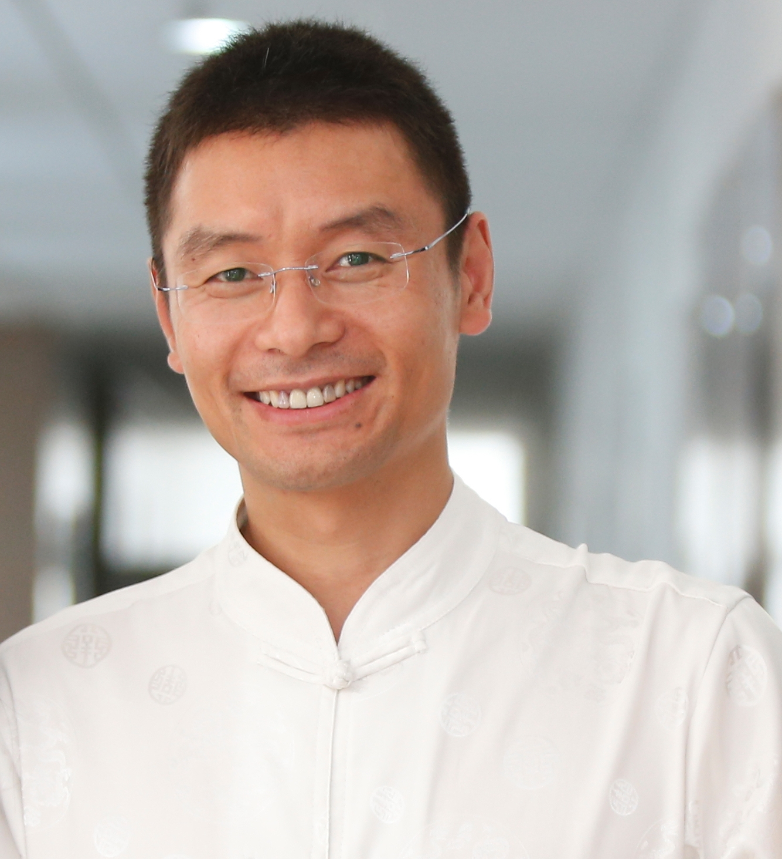 | Mobile Phone: 1391 125 5085  Telephone: 010-8577 8039  E-mail:ccmzhang@163.com  Add.: Room 1503, 11th Building,  Xinglong Garden, No.29 Jianguo Road,  Chaoyang District, Beijing  100025 China
Objective | To be a senior manager in NGO and start my new Non-Business life
Working Experience | Aug.2014–current China Arts Collection Beijing  Deputy Vice General Manager  Take the full responsibility of the company (the former PIT) operation, including sales, project management, after sales service and one small product assembly line in China.  - Make the company strategy plan.  - Establish the management system, including organization system, marketing and sale plan, performance pay system and management rules and standard system.  - Manage the company normal operation.  - Carry forward the national project of “China Handicrafts O2O chain trading platform”.  - Successfully achieved the strategic target of the first half year 2015.
Mar. 2013–Jul. 2014 Beijing FHCC Culture Development Co., Ltd Beijing
Managing Director / Training Consultant
- Take the full responsibility of the company operation.
- Successfully cooperated with Changsong Consulting which is one of the top training and consulting Company is China.
- The trainees increased from 60/month to more than 400/month.
- The company turnover increased10 times.
- Get about 3000 enterpriser and managers trained.
Oct. 2010–Oct. 2011 Putzmeister(Beijing) Solid Pumps Trading Co., Ltd Beijing
General Manager
- Take the full responsibility of the company (the former PIT) operation, including sales, project management, after sales service and one small product assembly line in China.
March 2004–2010 Putzmeister Industrial Technology Beijing Office Beijing
Senior Sales Manager / Head of Sales Department
- Developing and expanding Piston Pump & Silo business in Coal Mining, Metal Mining and metallurgy, Hazardous Waste Handling, Organic Waste Handling, Dredging, Waste water treatment industries all over China
- Providing marketing strategies and sales policy for the market of each industry. Including price policy, sales strategies and determine profitability
- Selecting, managing, training & supporting distributors & agents
- As team leader succeed in leading, guiding, supporting and encouraging team members to achieve sales target
- Creative and productive of new applications due to experienced and strong technical background of pumping technology.
- Succeeded in pushing PM Piston Pump into Chinese coal mines since year 2005 which Putzmeister never done before
- Succeeded in pushing PM Piston Pump into Aluminum industry since year 2006 which Putzmeister worldwide never done before
- Succeeded in pushing PM Piston Pump into Chinese coal fuel power plant since year 2006
- Succeeded in pushing PM Piston Pump into Chinese cement plant since year 2007
- Succeeded in pushing PM Piston Pump into Chinese Steel Plant and Dredging market since year 2008
2000.10–2004.2 seepex Seeberger GmbH Beijing Office Beijing
Sales Manager
- Developing and expanding Progressive Cavity Pump business in Environmental, Oil & Petrochemical, food & beverage, pulp & paper, Chemical and Mining industries within the Northern Provinces of China
- Providing marketing strategies and sales policy for HQ in North China market and China Market
- Developed very closed business relationships with customers (including OEM's, Engineering Co's, End User's & Design Institutes), Especially in Environmental, Oil & Petrochemical, Mining, and pulp & paper industries
- Suggested new solution and renovation of product to HQ base on sales and service experience in China
- Selecting, managing, training & supporting distributors & agents
- Arranging the inspection in Europe for Chinese customers
- As team leader succeed in leading, guiding, supporting and encouraging team members to achieve sales target
- Equipment commissioning & service
- Doubled territorial sales very year (2001-2003)
1998.03–2000.10 ITT Flygt Pump Co. Beijing Office Beijing
Sales Engineer
- Developing and expanding Submersible Pump business in Environmental, Oil & Petrochemical, Chemical and Mining industries within Beijing Area
- Providing marketing strategies and sales policy
- Developing and maintaining business relationships with existing and potential customers
- Holding seminars for Design Institutes
- Participating in bidding projects
- Selecting, managing, training & supporting distributors & agents
- Equipment commissioning & service
1995.07–1998.02 Chaoyang Foodstuff Group Beijing
Manager Assistant / Department Manager
- Participated the preparation, establishing & operation of a supermarket
- In charge of the stocking, storage & sales of merchandise
- Developing & maintaining relationships with relative government officers
Training | 2012-2014 Participated a lot of trainings Beijing  Leadership trainning, Coaching Skills,Comunication skills , Satir Family Reconstruction,China Confucianism,Buddhism and Taoism training.etc.
April 2004 Putzmeister AG Sttutgurt, Germany
- International sales training
- Whole operation process of Putzmeister AG
- Piston pump maintenance & repair
October 2001 seepex Seeberger GmbH + Co. Bottrop, Germany
- Whole operation process of seepex
- Progressive Cavity Pump assembly, maintenance & repair
- International sales training
September 1999 ITT Flygt (Shenyang) Co., Ltd. Shenyang,China
- Submersible Pump assembly, maintenance & repair
- Whole operation process of 100% foreign venture in China
Education | 2007.01–2009.5 Remin University of China Beijing,China  - EMBA (Executive Master of Business Administration)  - The thesis is top five among EMBA graduates 2009 of RUC  1999.09–2000.07 Beijing University of Chemical Technology Beijing,China  - Computer technology and applications  1993.09–1995.06 Center University for Nationalities Beijing,China  - Environment and Chemistry  - Chairman of the student union  - Gained the permanent residence of Beijing city
Foreign Language | Fluently speaking and writing in English
Interests | Sports(especially basketball), Music, Singing, Traveling, Intercommunication
Others | Very interest in public welfare, Buddhist, Business coach, Coaching Manager, Beijing City Volunteer of 2008 Olympic Games, 3 months Voluntary teaching in Wenchuan (China earthquake area), made more than 100 public training courses for university, school, kindergarten, families about life plan, career plan, target achieving, family education and communicating.
张 伟  ( Michael Zhang)  性别: 男  年龄: 42  职称：工程师  中共党员  户口: 北京 |  | 手机: 1391 125 5085  电话: 010-8577 8039  E-mail:ccmzhang@163.com  住址: 北京市朝阳区建国路29号  兴隆家园11#楼1503室  邮编：100025
工作经历 | 2014.8-今 广州中艺尚旅商贸有限公司 工作地点：北京  职务：常务副总经理  - 负责制订公司工艺品事业部的发展战略。  - 负责建立公司的战略落地体系，包括组织系统、营销规划、薪酬绩效和各种管理规范。  - 负责推进了和筹建国家级平台《中国工艺品O2O连锁交易平台》。  - 负责公司工艺品事业部的日常运营。  - 至2015年6月底，超额完成了既定的战略指标。
2013.3-2014.7 北京福慧诚诚文化发展有限公司 工作地点：北京
职务：北京中心总经理、培训师
- 全面负责公司北京中心的运营。
- 负责制订公司的营销战略。
- 发起并主导了公司与长松咨询（国内组织系统建设第一品牌）的合作。
- 使公司的招生人数由60人/月提升至400人/月。
- 公司的营业额增长了10倍。
- 为约3000名民营企业家和高管提供过培训和训练。
2009.10-2011.10 普茨迈斯特（北京）固体泵贸易有限公司 工作地点：北京
职务（外企）：总经理
- 全面负责公司（前生是普茨迈斯特工业技术部-中国）在中国的运营。包括销售、项目管理、售后服务和国产化组装生产线。
- 制订公司的发展和营销战略。
- 制订公司的年度经营指标并负责执行。
- 制订公司的各项预算并进行控制。
- 制订销售和考核指标，并指导和支持销售团队完成指标。
- 负责公司的年度成本核算并对德国总部负责。
- 中国公司成为集团该事业部全球销售冠军。
2004.3-2009.9 同上 工作地点：北京
职务（外企）：销售总监
- 负责公司产品和系统（液压柱塞泵和料仓）在中国境内各个行业的推广和销售。主要行业有：煤矿、金属矿山、污水和污泥处理、生物废料处理、危废处理、水泥厂、电厂、清淤和钢铁厂等等。
- 负责制订各行业的营销战略。包括市场推广、产品定价、产品销售策略和盈利预测等等。
- 发展、选择和培训代理商或合作商。
- 制订销售指标，并指导和支持销售团队完成销售指标。
- 进行项目跟踪、参与投标，并签订销售合同。
- 根据已有的销售经验和技术不断开发新的客户和应用领域，开创多个零的突破。
在2008年将公司产品首次推入中国的钢铁厂和清淤行业市场。
在2007年将公司产品首次推入中国的水泥厂市场，实现了中国市场零的突破。
在2006年将公司产品首次推入中国的火力发电市场，实现了中国市场零的突破。
在2006年将公司产品首次推入中国的氧化铝业市场，开创了公司全球的新应用的突破。
在2005年将公司产品首次推入中国的煤矿市场，后来成为国际行业排行第一。
2000.10–2004.2 德国西派克-西贝格有限两合公司（北京办） 工作地点：北京
职务（外企）：销售经理
- 负责公司产品（单螺杆泵）在中国华北地区各个行业的推广和销售。主要行业有：污水和污泥处理、石油化工、饮料、造纸、化工和矿山等等。
- 制订公司产品在华北地区的市场推广和销售策略。
- 跟不同类型的用户，如最终用户、工程公司、OEM和设计院等，建立稳定的合作关系。
- 根据已有的销售经验和技术为产品提出改进，或开发新的应用。
- 发展、选择和培训代理商或合作商。
- 组织和安排客户赴欧洲考察。
- 指导和支持销售人员完成销售指标。
- 进行项目跟踪、参与投标，并签订销售合同。
- 提供设备的调试和技术服务。
- 多次刷新公司的销售记录。
- 在2001年至2003年间，每年都实现销售翻番。
1998.06–2000.9 瑞典ITT 飞力泵业有限公司（北京办） 工作地点：北京
职务（外企）：销售工程师
- 负责公司产品（潜水泵）在北京地区建筑行业的推广和销售。
- 参与制订产品的市场推广和销售策略。
- 发展、选择和培训代理商或合作商。
- 发展和建立良好的客户关系。
- 在设计院组织和开展产品介绍和推广会。
- 进行项目跟踪、参与投标，并签订销售合同。
- 提供设备的调试和技术服务。
- 公司营销技能通关冠军。
1995.07–1998.04 北京市朝阳区副食品批发总公司（百惠超级市场） 北京
职务（国企）：经理助理 / 部门经理
- 参与超级市场的组建、运行和管理。
- 作为实物负责人，负责所管辖部门所有商品的进、销、存。
- 参与协调单位与相关各政府部门的关系。
- 总公司优秀党员。
- 在确保自己所负责的百货部门毛利稳定在20%后，又接手了食品部门，半年后让食品部门扭亏为盈，毛利也达到了20%。
教育 | 2007.01–2009.5 中国人民大学 学习地点：北京  - EMBA （高级工商管理）  - 班委、优秀毕业论文（超优势竞争理论）  1999.09–2000.07 北京化工大学 学习地点：北京  - 计算机技术和应用（专升本，后来因工作关系弃学）  1993.09–1995.06 中央民族大学 学习地点：北京  - 环境化学专业  - 班长、系学生会主席  - 以综合测评第一名的成绩获得留京工作指标
外语 | 英语说、写熟练
爱好 | 沟通和交流、写作和分享、运动（特别是篮球）、音乐、唱歌、旅游等等
其他 | 十分钟爱公益事业，信仰佛教并包容尊重各种宗教信仰。是资深企业教练，教练型领导力培训专家，2008年奥运会优秀城市志愿者，2011-2012汶川支教老师，热衷研究家庭教育和家庭关系促进，做过多场公益培训。

