**YAN LI** 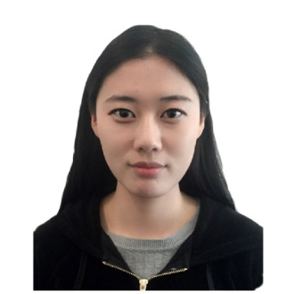

Room 2701,NO.18,Xinhaochang Jiashuyuan, Jinhua South Road, Xincheng District, Xi’an, Shaanxi, 710048. Tel: +8613619258630, +447518216277 Email: [290797170@qq.com](mailto:290797170@qq.com); [leedapplefire@gmail.com](mailto:leedapplefire@gmail.com)

**Education**

**2014-2015 The University of Manchester (UK)**

**MA Sociology , Master**

* Utilised both primary and secondary research sources, conducting 12 interviews to produce a paper
* Developed skills in both quantitative and qualitative research methods
* Living and studying in UK has broadened my appreciation of cultural differences and enabled me to sensitively adapt my approach to new environments
* Improved English language

**2012-2015 Northwest University (CHINA)**

**MA Journalism, Master**

* Undertook a group project on behalf of Journalism department of Northwest University
* Developed skills in edit and communication methods

**2008-2012 Xi’an International University (CHINA)**

**BA Journalism, Bachelor**

* Achieved a first class grade for the dissertation
* Developed skills in writing, photography and video methods

**2004-2008 Zhongtieyiju High School ( CHINA)**

**Relevant work experience**

**May – July 2012 ‘The planning of advertising the image of Xi’an Chanba International Ecological area’**

* Set up some appointments with residents through cold calling and oral communication. Successfully meet them and acquired their attitudes and expectation of Chanba area. This has helped to improve my confidence in my negotiation and communication skills
* Conducting about 100 questionnaires and writing a report to present the findings, which developed my writing, editing and presenting skills
* Using social media and mobile applications to spread positive images of Chanba area, which benefits to the skills of using social media

**March—June 2012 Writing and editing the book of the new trend of the development of building well-off society in West area of China 2013**

* Developed writing, editing and presenting skills

**July—September 2011 Journalist , Sanqin Newspaper**

* Finding, writing and editing news enabled me to develop sensitivity of news
* Interviewing people on the street makes me have strong confidence and affluent communicate skills
* Worked with editors and journalists to influence the direction of both existing and future publishing news

**January---March 2012 Journalist, Shaanxi Broadcast Television Station**

* Team work enabled me to have the coordinate ability
* Thinking and creating new idea about every program improved my creative thinking
* Writing program reports developed skills of copywriting
* Conducting a video enabled me to deal with unexpected and emergency things
* Developed editing videos skills

**Positions of Responsibility**

* The single scholarship of Northwest University 2013
* The first class scholarship of Northwest University 2014
* The monitor of literature and art department in 2012-2014
* The certification of Interview and Edit of News

**Additional Skills**

**IT**

* Proficient in the use of Microsoft Office, including Excel to create spreadsheets and analyse complex data sets
* Using Photoshop to edit photos

**Languages**

* Fluent English (CET6 and IEITS)

Class 1 level of Mandarin

**Driving**

Full clean driving licence

**Interests and Activities**

**Societies**

* Visiting Geracomium as a volunteer before I went abroad to study

**Sport**

* Running and Swimming

**Art**

* Dancing