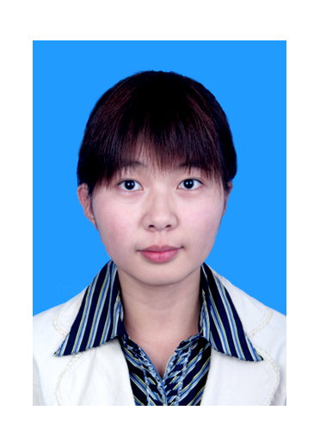
龚佳
电话: 13811989924 邮箱: Jane953@163.com
身高： 168cm 出生年月： 1985年09月

求职意向 行政助理
教育背景
2004.09 –2008.06 北京林业大学 英语专业（商务方向） 本科
工作经历
2007.06—2008.07 麦德龙锦江现购自运有限公司 楼层经理助理实习生
担任行政兼销售部门楼经助理，负责员工考勤，有关文件的处理，收发邮件，信息搜索及整理，联系各部门并及时将有关信息传达到位

2008.08--2012.08 科尼希鲍尔印刷机械（上海）有限公司北京分公司 行政秘书
• 商务接待
• 员工招聘及入职安排
• 文件管理、办公用品采购
• 员工财务报销并填制财务报表
• 准备项目标书及相关文件、为销售及服务部门提高助理支持
• 员工行程安排、票务及车辆安排
• 协助客户出国考察、与德国总部沟通事宜
• 领导安排的其他事务
2012.09--2015.02 兼职翻译及家教
2015.04--至今 长城脚下的公社 预定专员
• 个人及团队的客房预订、更新相关报表数据
获奖情况
2006年-2007年 校二等奖； 校优秀学生干部
个人技能
- 外语技能 ：英语专业八级
- 计算机技能 ：熟练运用office等办公软件
- 其它技能 ：国家中级公关员、会计从业资格
个人爱好与特长
- 喜爱阅读各类书刊，慢跑，影视欣赏,旅游等
- 英语基础牢固，善于处理人际关系，有独立承担英语翻译的能力，团队意识强
个人评价
- 为人： 守信，耐心，积极乐观，善于倾听并与人沟通
- 工作：认真负责，富于创新， 善于与人合作，不断追求进取
Jane Gong
Tel.: +86-13811989924 Email: Jane953@163.com

Job Objective： Administrator

Education
Sep., 2004–Jul., 2008 Beijing Forestry University English Major

Work Experience
Jun., 2007 – Jul., 2008 Assistant to the FMs of Metro at BJ Shilihe
Duties:
- Designing related programs, responsible for negotiation with departments and making information known
- Statistics daily sales reports
- Translating materials for the Store and related activities
Aug., 2008 – Aug., 2012 KBA Printing Machinery (Shanghai) Co., Ltd. Beijing Branch
Administrator
Responsibilities:
• Answer incoming calls and professional greeting of clients
• Staff recruitment and induction training
• File management and office stationary purchasing and management
• Process basic accounts payable invoices and process expense reports
• Co-ordinate on preparation of project documents and secretarial assistance to Sales and After sales service departments
• Manage e-calendars for colleagues and set appointments， car arrangement
• Assist on Customer’s abroad business investigation and communication with German Headquarter on related issues
• Other jobs that maybe assigned
Sep., 2012 – Feb., 2015 Part-time Translator and tutor
Apr., 2015 – Now Commune by the Great Wall
Reservation Clerk
Responsibilities:
• Deal with reservation issues for Individual and Team guests, update related reports and data

Scholarship & Honors
2006- 2007 The Second Class Scholarship, Excellent Student Leader

International Languages Tests
English TEM－8

Other Skills
• Skilled in the use of Office software, Word, Excel, PPT and Outlook, etc
• Qualified for Accounting

Hobbies
Jogging, basketball, movie and music appreciation, traveling, reading, etc

