SHUYANG CUI

Email: shuyangcui@hotmail.com
Tel: +8613453146191
Skype ID: Shuyang Cui
EDUCATION
09/2013-09/2014 The university of Sheffield
MSc Environmental Change and International Development:
Dissertation: Climate Policy Making in Coal industry——Take Shanxi China as an example

09/2009-06/2013 Hunan University of Science and Technology, China
BSc Resource and Environment Management, Urban and Rural Planning (Overall mark82% equivalent to2:1)
Dissertation: the Application and Development of Building Energy Efficiency Technology in Northern and Southern China——Take Taiyuan and Changsha as examples
WORK EXPERIENCE
06/2015-07/2015 Consultant in New Oriental Vision Overseas Consulting Co., Ltd. Hunan Branch (Changsha, Hunan)
I provided professional suggestions and schemes of applying for the universities and high schools in the US to my clients, I gain sales technique and became an expert of the US schools application.
01/2015-05/2015 Volunteer teacher in Dongguan Primary School (Luliang, Shanxi)
Being a volunteer teacher in a remote region where I am teaching pupils English and Chinese, I improved my empathy, communication skills and learned how to motivate other people.
06/2014-09/2014 intern in Shanxi Province Environmental Protection Bureau, (Environment Evaluation Department)
I collected data and assisted in examining and approving the development of coal enterprises, I have developed analytical, organization, time management and teamwork skills.
02/2013-05/2013 intern in Shanxi Institute of Education (Taiyuan, Shanxi, China)
I developed interpersonal skills and time management skills by provided office administrative support and operating switchboard; handling internal and external queries and providing reception support and adhoc duties as and when required.
IT KNOWLEDGE
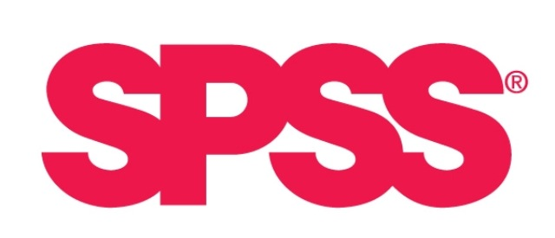
OTHER SKILLS
Bilingual in Mandarin and English; good at drawing and event planning.

