**安爽**

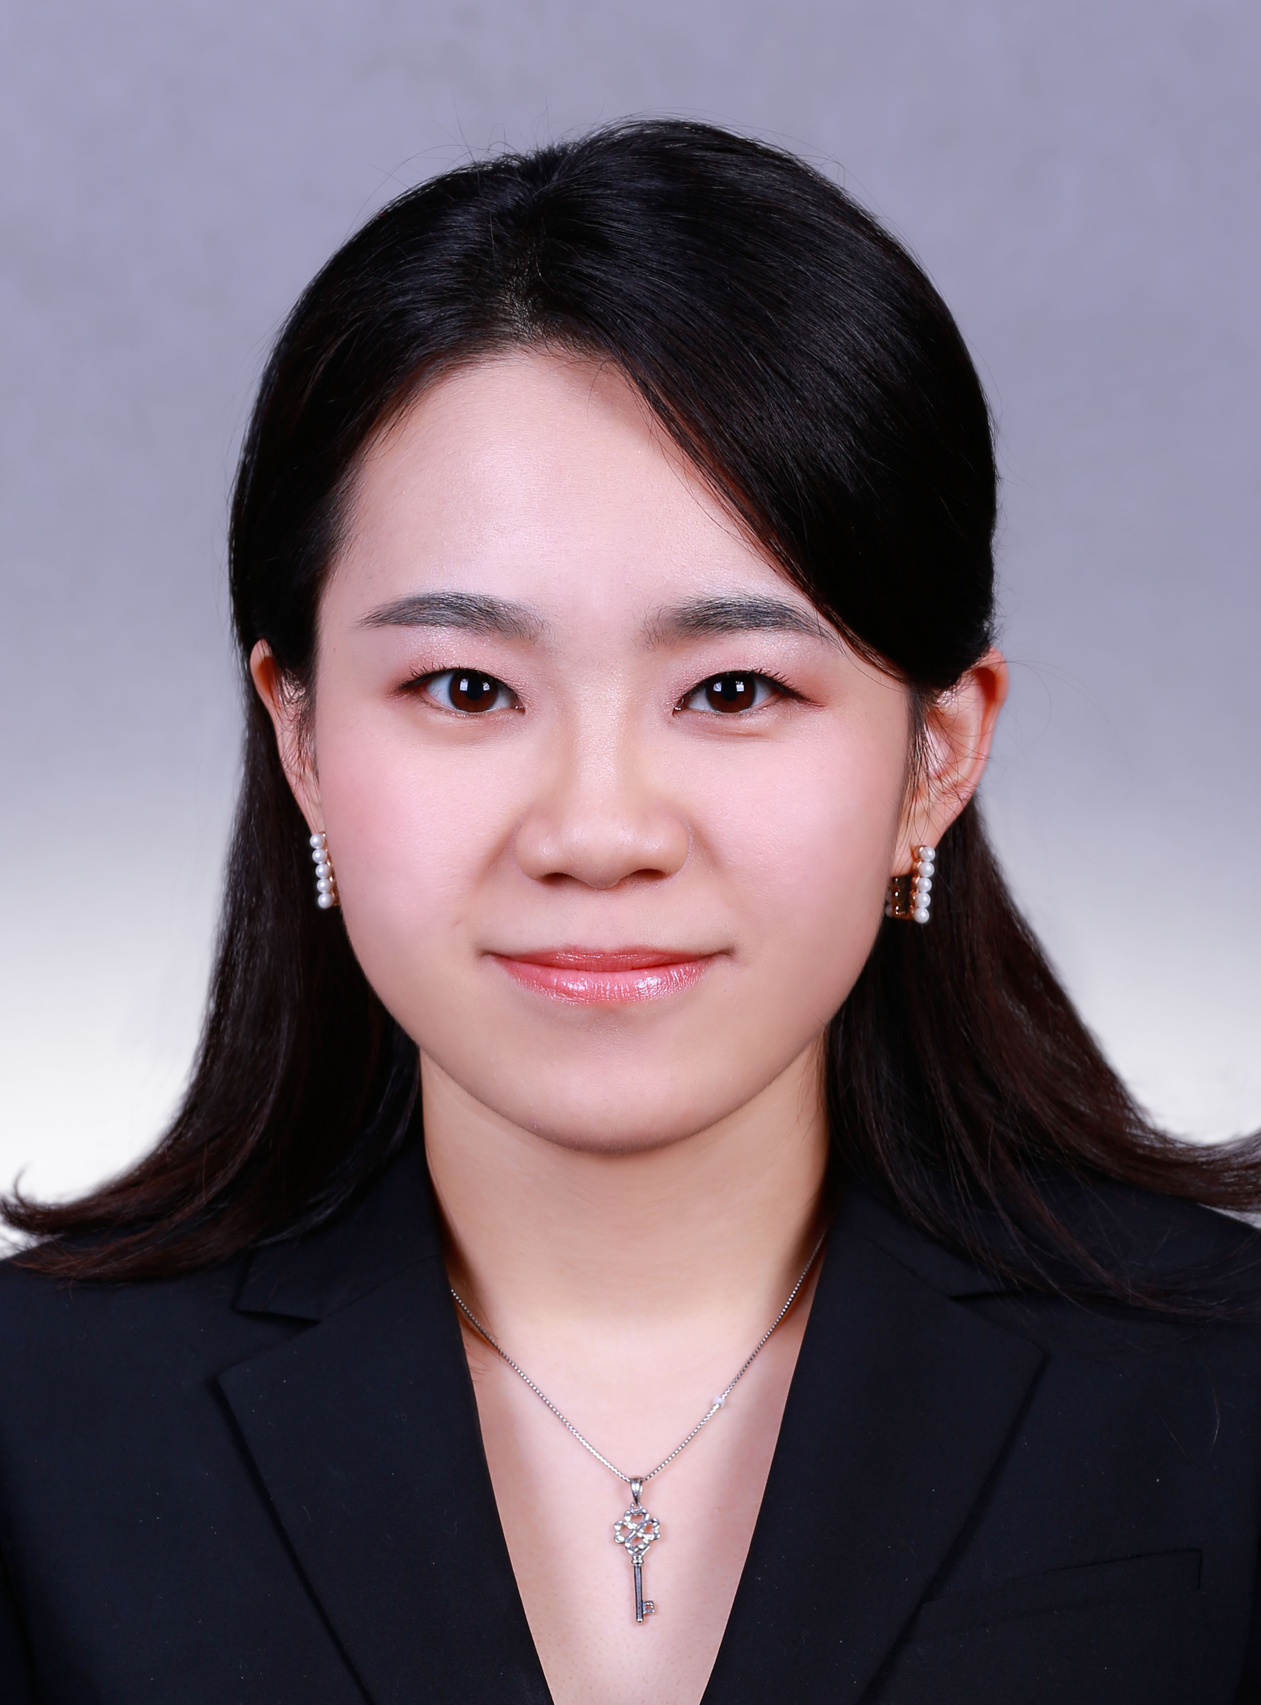

地址：北京市西城区

邮箱：[18911095260@163.com](mailto:18911095260@163.com)

手机: +86 18911095260

**教育背景**

**美国南加州大学 洛杉矶 8/2010-12/2012**

传媒学院 战略公共关系专业 硕士学位

**中国人民大学 北京 5/2015-今**

经济学院 金融与投资实务专业 在读硕士

**首都师范大学 北京 9/2006-6/2010**

文学院 汉语言文学专业 学士学位

**工作经历**

**哲基杰讯咨询公司 资深顾问 北京 5/2014-Present**

* 为纳斯达克和港交所上市公司提供投资者关系战略咨询，客户包括摩根士丹利、中国建设银行、中国人寿保险、瑞士宝盛银行、黑石集团和嘉民集团等
* 为大型国有企业并购和债券发行提供咨询，统筹调配伦敦/美国信息资源，分析竞争对手情况并设计模拟问答，拟定危机策略并处理临时突发案件，顺利渡过当地政府换届及群体抗议等危机， 保证并购资产顺利交割及债券成功发行
* 拟定投资者关系/公共关系策略，撰写业绩发布文稿、董事长致辞和内部通讯等文案

**万博宣伟公关公司 资深客户主任 北京 6/2013-4/2014**

* 负责微软品牌塑造及营销策划，包括制定微软全球副总裁来华采访计划、筹办全球合作伙伴大会及录制教育电视台节目等，推广了微软助力中国转型、重视企业社会责任的正面形象
* 与国务院发展研究中心、工业和信息化部及知名大学专家合作，发布安全情报白皮书并直投 8053位省级以上政府官员和企事业单位经理级以上管理人员
* 参与Windows XP退役危机处理，负责拟定应急预案和处理媒体问询等，成功扭转70%偏激舆论导向，Windows XP停服当天65%以上媒体报道均为中立或正面

**CCG投资者关系公司 市场和媒体关系专员 洛杉矶 2/2012-5/2013**

* 制定宣传发布计划，撰写新闻及媒体分析报告，拓展维护与当地媒体的良好关系
* 进行认知调研并收集信息， 为不同行业客户制定路演、IPO和兼并收购的财经公关策略
* 组织策划年度会议及活动，包括洛杉矶罗斯投资者年度会议及全球游戏开发者会议等,《华尔街时报》及《中国日报》进行了相关报道

**CNBC美国国会改革论坛 策划部实习生 洛杉矶 3/2011-8/2011**

* 制定并实施论坛活动策划，联系场地、设计展台、调配人员、安排日程
* 协助拟定宣传策略以及安排协调媒体采访，邀请媒体、分析师和关键意见领袖，中央电视台及《洛杉矶时报》进行了相关报道
* 撰写新闻稿件及报告，并负责社交媒体宣传, FOX及CNBC进行了相关报道, 各大社交媒体网站点击率破万

**资格证书**

全国翻译专业资格英语二级口译 (2014年)

大学英语六级，托福110分，GRE1330分 (2010年)

Google Analytics 分析个人认证 (2012年)

**社会活动**

南加州大学中国学生联合会秘书 (2011年) 南加州大学中美学院学生干事 (2012年)

北京奥运会男子排球学生志愿者负责人 (2008年)

**技能专长**

英文听说读写流利，担任过福特基金会学者及深圳政府城市发展考察团陪同翻译 熟练使用Microsoft Office软件

HTML简单操作

熟练使用图片处理软件Photoshop/ Illustrator

**Serena An**



Xicheng District, Beijing

E: [18911095260@163.com](mailto:iamanshuang@gmail.com)

T: +86 18911095260

***EDUCATION***

**University of Southern California Los Angeles 8/2010-12/2012**

M.A. in Strategic Public Relations

**Renmin University of China Beijing 5/2015-Present**

M.A. candidate in Economics

**Capital Normal University Beijing 9/2006-6/2010**

B.A. in Chinese Language & Literature

***WORK EXPERIENCE***

**Citigate Dewe Rogerson, Senior Consultant Beijing 7/2014-Present**

* Provided investor relations (IR) advisory for the US and HK-listed companies, my client responsibilities include Morgan Stanley, CCB, Julies Baer, Blackstone, Oaktree and Goodman
* Took lead in M&A and bond issuing advisory for Chinese SOEs, allocated resources among London/U.S., built insightful peers analytics and strategic Q&A scenarios, managed crisis during national political referendum/labor union resistance, and ensured smooth closing of acquired asset and successful bond issuing
* Drafted IR/PR plans, Chairman statements, press release and newsletters

**Weber Shandwick, Senior Associate Beijing 6/2013-7/2014**

* Responsible for corporate marketing planning, including Global VP’s visit, presencein blockbuster TV programs and World Partner Conference, successfully amplified Microsoft’s contribution to China’s transformation and its corporate social responsibility.
* Worked closely with experts of Development Research Center of the State Council, Ministry of Industry and Information Technology and renowned universities to launched Security Intelligence Whitepaper, email direct marketing reached 8,053government officials and business decision makers
* Drafted emergency management plan and handled media inquiries for Windows XP End of Services crisis, successfully reverted 70% negative opinions and received more than 65% of neutral to positive coverage on the day of its retirement

**CCG Investor Relations Agency, Marketing and Public Relations Specialist Los Angeles 2/2012-5/2013**

* Developed editorial calendars, press materials and media reports for clients in a variety of industries
* Conducted perception studies and developed financial communication strategies for clients’ non-deal roadshows, IPOs and Mergers & Acquisitions
* Managed grand events including Annual Roth Stock Conference and Game Developers Conference in San Francisco, received in-depth coverage from *Wall Street Journal* and *China Daily*

**CNBC eCongress Panel, Event Coordinator Los Angeles 3/2011-8/2011**

* Developed event planning for the summit, responsible for logistics including venue selection and setting up, itinerary arrangement and manpower allocation
* Designed communication strategies and arranged onsite interviews, outreached business press/analyst/blogger communities and received coverage from *CCTV* and *LA Times*
* Composed press materials and managed social media communication, the panel drew local and national media exposure from FOX, CNBC and over 10,000 online viewers

***CERTIFICATE***

TOFEL 110 points, GRE 1330 points

Translators and Interpreters Advanced Level (China Accreditation Test)

Google Analytics Individual Qualification

***SOCIAL ACTIVITIES***

VP in USC Chinese Students & Alumni Association Student Advisor in USC US-China Institute

Volunteer Manger of 2008 Olympic Games Men’s Volleyball Games

***RELEVANT SKILLS***

Language: English, Mandarin and Cantonese HTML coding

Computer proficiency with Microsoft Office Graphic design with Photoshop/ Illustrator