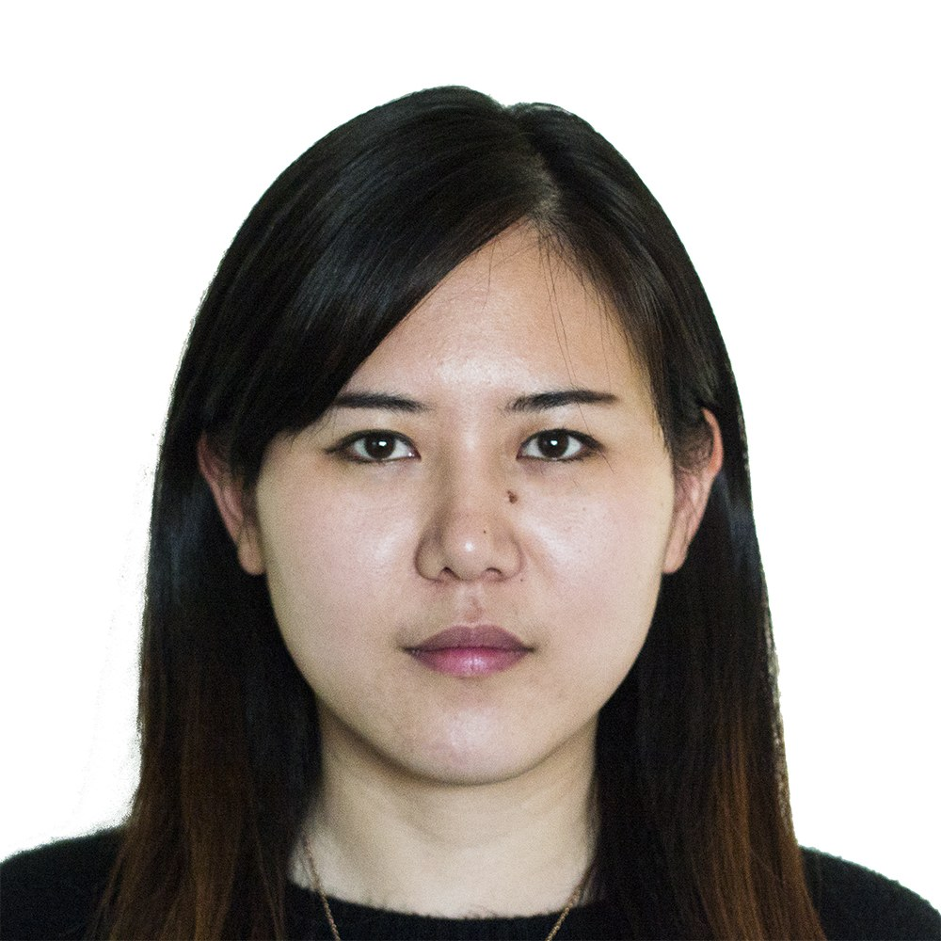**欧阳吴攸**

18311007218

weilong51_happy@126.com

**教育背景**

**旧金山大学 亚太研究专业 研究生 2011年9月 – 2015年5月**

(主修课程：东亚的现代化，当代东亚的社会与文化等)

**北京师范大学 法学专业 本科 2007年9月 – 2011年7月**

**实习经历**

**美世咨询有限公司 实习生 2014年 11月 – 2015 年5月**

* 招聘测验开发：参与开发领导力潜能测验、岗位个性能力测试、结构化面试指南、专业技能Excel测试；搭建岗位招聘手册；联络实施Pilot试测、参与撰写试测报告（甲方：宝马）
* 测评工具开发：参与开发与翻新AC测评商业模拟、角色扮演、无领导小组讨论案例
* AC 测评：电话联络测评人；担任观察员与协调员；撰写与审核个人报告；撰写团队报告
* 岗位模型翻新：参与能力模型翻新、职级序列划分；编制测评报告生成器、个人报告模板（甲方:一汽-大众）
* 组织架构咨询：参与组织架构优化项目、参与数据分析和制作报告（甲方：奥迪）
* 调研与翻译：项目调研与对标分析；翻译多个项目建议书与项目报告

**基金会中心网（基金会培训中心） 项目助理 2013年1月 – 7月**

* 秘书长必修课程开发项目：参与调研阶段访谈与问卷回收；参与撰写项目中期报告、财务报告和项目总结；制定工作计划；组织会议、负责外部联络；负责项目的资金管理和行政事务。（资助方：赠与亚洲）

**公共环境研究中心 志愿者 2012年7月 –10月**

* 定位中国煤炭行业上市公司的关联关系，撰写《电力煤气水行业污染调研报告》大纲
* 帮助完善污染及环境违规记录数据库

**校园活动**

**旧金山流浪汉救助工程** **志愿者 2012年4月**

* 担任旧金山政府的流浪汉救助工程志愿者，在大型救济会上提供登记和翻译服务

**北国剧社（北京市大学生话剧团） 2008年 2月 – 2011年6月**

* 担任多部话剧主演或配角；担任短剧导演。参演的《安妮日记》得以商演。
* 四年内在大量舞台剧中担任服装、道具、导演助理、舞台监督等各种角色。

**个人描述**

* 出色的中文水平、流利的英文水平
* 熟练操作Excel, Word, PowerPoint 办公软件。
* 学习能力强。关注细节，善于计划，逻辑、条理性强，工作可靠。思维开阔，喜爱创意。对一些人文社科类议题有独到见解。

**Ouyang Wuyou (Jenny)**

18311007218

[weilong51_happy@126.com](mailto:weilong51_happy@126.com)

**Education**

**University of San Francisco, Master of Asia Pacific Studies Sep. 2011 – May. 2015**

( Courses include: Modernization of East Asia, Culture of Contemporary East Asia, etc.)

**Beijing Normal University, Bachelor of Law Sep. 2007 – Jul. 2011**

**Internship experience**

**Mercer Management Consulting Intern Nov. 2014 – May. 2015**

* Recruitment Tools development: Participate in developing Leadership Potential Test, Situational Judgment Test based on the post competency model, Structured Behavior Interview Instruction,and Professional Excel Test. Put up Recruitment Handbook. Coordinate to implement Pilot Testing, and participate in writing Pilot Testing Report. (Party A: BMW)
* Assessment Tools development: Participate in developing and renewing AC Business Stimulation, Role Play and Leaderless Group Discussion Case.
* Assessment Center: Call and inform participants; play coordinator and observer in assessments; write and review individual reports; write group reports.
* Position Model Renew: Participate in renewing post competency model and sequence division; develop individual report template and generator. (Party A: [FAW-Volkswagen](http://dict.youdao.com/w/faw-volkswagen/))
* Organization Structure Consulting: Participate in data analysis and report writing. (Party A: Audi)
* Research and translation: Research and benchmark for projects. Translate several BD Proposals and Project Reports.

**Chinese Foundation Training Center Project Assistant Jan. -July. 2013**

* Course Development Project(Compulsory Course for Foundation Secretary): Participate in interviews and collecting questionnaires; participate in writing interim report and financial report; write work plans; take charge of meeting organization and liaison; take charge of financial and administrative jobs. (Donor: Give 2 Asia)

**Institution of Public Environment Volunteer July. - Oct. 2012**

* Identify related parties of listed company of coal industry in China. Write the draft of the report on the pollution of the biggest listed companies of Chinese coal industry.
* Help improving the pollution record databases.

**Activities**

**San Francisco Homeless Project Volunteer Apr. 2012**

* Assist in translation and sign-in in a big service project held by government.

**Beiguo Drama Club Club member Feb. 2008 - Jun. 2011**

* Was actress in several stage plays, in which *Diary of Anne Frank* got into commercial market.
* Worked as different roles of many stage plays throughout college, such as costume and props, assistant director, script supervisor and stage manager.

**Self-description**

* Excellence in Chinese. Proficiency in English
* Proficiency in Microsoft Office Software (Excel, Word, PowerPoint)
* Attention to details, organized and reliable in work, good planner with great logic. Creative thinking, open minded. Special attention to humanitarian issues.