**Ge Xingfang** **Teamwork / Responsibility**

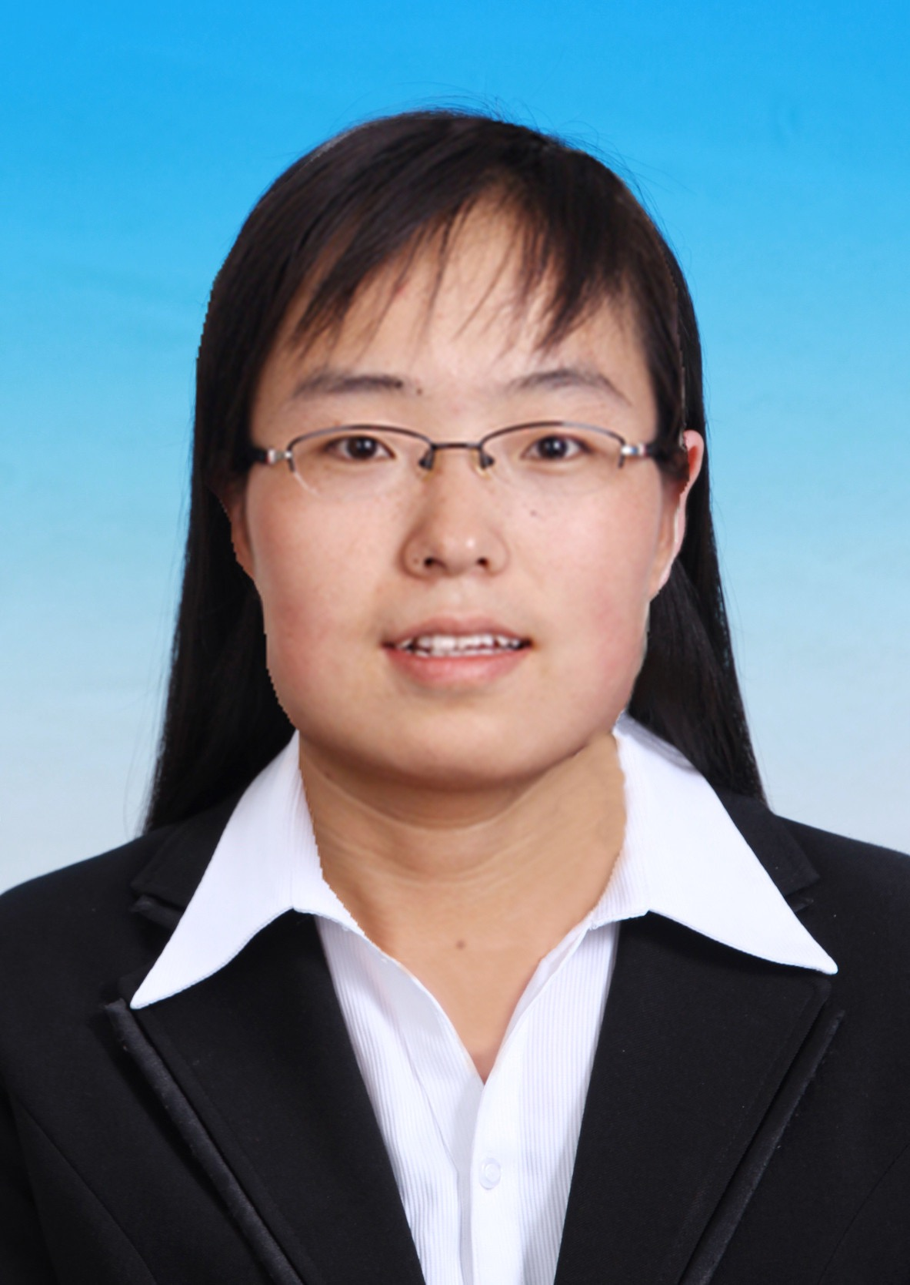Birth Date: **1985.03.17** From: **Shanxi, China**

Degree: **Doctor**

E-mail: [**sanhu_lyyl@163.com**](mailto:sanhu_lyyl@163.com) Tel: **15810016363**

**Education**

* Wildlife Conservation, Master and Doctor, Beijing Forestry University,

2008.9－2014.7.

**Familiar with medicinal or edible wild animals and plants protection**

**and utilization.**

* Biological Science (Animal oriental), Bachelor, Shanxi Agriculture University, 2004.9－2008.7.

**Familiar with phytology, zoology, microbiology and other biology professional foundation**.

**Work Experience**

* Shaanxi Endangered Wildlife Rescue Center, 2009.7-9;

Shaanxi Feng County Musk Deer Breeding Center, 2010.6;

Gansu National Endangered Wild Species Conservation Center, 2010.7-8;

Xinjiang Prewalskii Horse Breeding Center, 2011.5-9;

Shilin Rhino Breeding Center,2012.7-8.

**Familiar with local customs, adapt to the local customs of life.**

* College of Nature Conservation, Beijing Forestry University, 2014.2-2015.6.

**Worked as a project assistant, responsible for project apply, mid-term evaluation, audit, acceptance and lab management, including supplies purchase and reimbursement.**

**Research activities/paper**

* Published 7 academic articles, had a good writing in English and Chinese language.
* Helped tutor search and collect domestic and foreign research progress, organized information in both English and Chinese. Participated in a number of research projects, including Special Forestry Public Welfare Industry Research, the National Natural Science Foundation, National 11th five-year Plan Project, etc.
* Strong mind and hand ability, as the first inventor to declare a national invention patent. Be good at observing life, thinking active, love to write, published 6 popular science articles as the first author.

**Campus activities**

* As a class psychological committee member, English class monitor.

**Awards**

* Ⅰ&Ⅱ Graduate Scholarship; National Graduate Scholarship.
* Ⅲ Undergraduate Scholarship; Excellent Foreign Language.

**Personal skills**

* Qualified in CET-6；Mandarin 2A；National Computer Rank Examination Grade 2; Three counselors Certificate； Proficiency in Microsoft Office applications.

**Personal Interest and Self-Assessment**

* Love to play badminton, table tennis, swimming；Raising fish, dog and flowers，keen on animal welfare; Warm and cheerful, optimistic in the face of difficulty, and active to solve the problem; the good team quality and team spirit.