RESUME FOR ROSE YANG

701#-1-503 Raycom City, Wangjing, Beijing rose_yang@hotmail.com Mobile: 13699210875
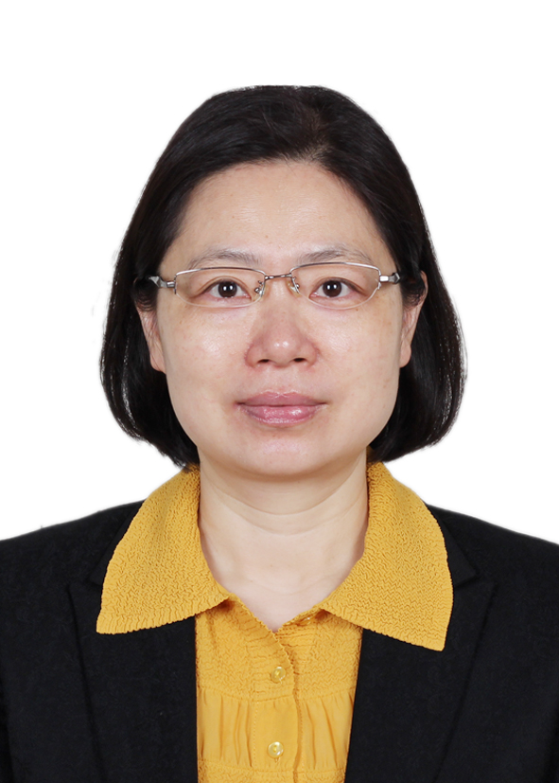

OBJECTIVE Senior Partnership Officer

PROFILE
- More than 20 years working experience in financial & enterprise management
- Large State-owned, foreign enterprise and overseas work experience
- Fluency in Chinese and English
- Work independently as well as in team environment
- Excellent communication skills
- Passion for charity and humanitarian work

NGO EXPERIENCE

2010-now Volunteer, Ya Li Foundation
- Program Officer for Ya Li Scholarship (a charity project of Ya Li Foundation, aiming to support financially high school students from the less privileged families to go to universities)
- Raise fund for Ya Li Scholarship
- Liaise and follow-up with school principals, teachers, parents and students on behalf of Ya Li Scholarship
- Assist the Admin tasks to ensure the smooth implementation of the project

Business Experience
2011-now  2008-2010 | Chief Representative, Kryso Resources Limited Beijing Representative Office (www.kryso.com)  - Reporting to Managing Director of the company  - Responsible for the business liaison in China with the head office in UK  - Taking full charge of accounting/Finance/HR/Admin in Beijing office  - Reporting monthly financial statements to the Head office on time  - Managing the procurement and logistics of equipments and materials in China for company  - Responsible for the daily smooth operation of Beijing office  Financial Controller, Six Sigma Breakthrough Technologies International-China Limited Beijing  - Took full charge of the overall financial and managerial accounting, tax, budget and examining the Beijing/HongKong/consolidated financial statements and leading the finance team for SBTI China  - Maintained the good relationship with related government bureau such as business administration/tax/foreign exchange bureau  - Communicating and laision with HongKong accountant  - Reported monthly consolidated financial statements to SBTI US (Head Office) and Greater China CEO and solving all kinds of concerns and questions from the US head office  - Responsible for SBTI China’s risk management and communicated with the company’s lawyer in a timely manner and successfully solved several urgent events for SBTI  - Took charge of fund management and guaranteed the required cash flow for the smooth operation of the company  - Participated strategic projects and business negotiations and promoting strategic customers to sign the contracts
2004-2007 | Financial Consultant, Primerical Financial Services Vancouver  - Life insurance consulting  - Mutual fund investment consulting  - Got Diploma of Accounting from University of British Columbia, Canada  - Got life insurance and mutual fund license from Canada
1998-2001 | Accountant, Emerson Electric (China) Holdings Co. Ltd., Beijing Office  - Responsible for the full accounting cycle, payroll, budgeting and tax report for the company and reported directly to the Financial Controller.  - Prepared monthly financial statements including B/S, I/S, and cash flow statement on a timely basis to Emerson’s head office (based in St. Louise, MO, USA) for consolidation.  - Processed and audited employee expense reimbursements.
1991-1998 | Legal Assistant/Junior Accountant, China National Chemicals Import & Export Corporation (Sinochem), Beijing  - Daily bookkeeping and prepared month-end and year-end trial balance and general ledgers including A/R, A/P, accruals, sales, expenses, fixed assets, accumulated depreciation and foreign currencies, and reported directly to the Finance Manager.  - Assigned to WEPEC (a joint venture among Sinochem, French TOTAL and Dalian Economic Development Zone ) as the financial representative for Sinochem  - Responsible for Letter of Credit (L/C) business and studied L/C in Germany.  - Participated the financing activities for the holding company.  - Worked as legal assistant to help Sinochem’s lawyers handle the company’s legal affairs in the USA and negotiate with US lawyers and financial institutions and Proposed solutions to Sinochem management, and successfully reduced 13 million USD losses as a part of a three-member Sinochem team.

Education
9-10/2003 | Six Sigma Green Belt Training in Houston, Texas, USA
05/2002-12/2003 | Diploma of Accounting, University of British Columbia, Canada
1988-1991  1984-1988 | Master of Arts, Economics, University of International Business & Economics, China  Bachelor of Science, Engineering, Hunan University, China

References Available upon request.

杨承红简历

北京朝阳区望京融科橄榄城 503-1-701# rose_yang@hotmail.com 手机：13699210875

目标 Senior Partnerships Officer

个人档案
- 超过20年的财务和企业管理经验.
- 大型国企、外资企业和海外工作背景.
- 流利的中英文口语和书写
- 独立工作和团队合作的能力
- 优秀的沟通能力
- 对慈善和人道主义工作拥有热情

.

NGO工作经验

2010-现在 雅礼基金会自愿者
- 担任雅礼奖学金项目官员 (该项目为雅礼基金会的一个慈善项目，旨在资助来自弱势家庭的高中生上大学)
- 为雅礼奖学金筹款
- 代表雅礼奖学金和学校校长/老师/家长和学生联系
- 协助该项目的其他行政工作以使该项目顺利进行

商务工作经验

2011-Now  2008-2010 | 首席代表 科瑞索资源有限公司北京代表处  - 向公司董事总经理汇报  - 负责公司英国总部和中国的业务联络  - 全面负责北京代表处的会计/财务/人力资源/行政工作  - 管理公司在中国设备物资采购和物流工作  - 负责代表处的日常顺利运营  财务总监 中美六西格玛管理咨询（北京）有限公司 北京  - 全面负责公司的财务会计、管理会计、税务、预算和财务报表工作并带领公司的财务团队  - 维护公司与工商、税务、外管局等政府部门的关系  - 负责与香港会计师的沟通与联络，理顺了北京、香港、美国的财务关系  - 每月直接向SBTI 美国和中国区CEO汇报财务报表，解答美国总部的各种疑问并负责与美国总部的联络与沟通  - 负责公司风险管理，及时与律师沟通，成功解决几次突发事件  - 负责公司的资金管理，保证公司日常经营和急需的现金流  - 参与公司的战略项目及重大业务谈判，推动了战略客户项目的签约
2004-2007 | 理财顾问 Primerical Financial Services-花期集团成员之一 温哥华  - 人寿保险经纪服务  - 基金投资理财服务  - 获得加拿大哥伦比亚大学颁发的会计证书，  - 获得加拿大颁发的人寿保险和互惠基金经纪证书
1998-2001 | 会计及总经理助理 爱默生电器中国投资有限公司北京办事处  - 负责公司会计、工资、预算、税务、财务并向亚太区财务总监及总经理汇报  - 编制每月财务报表并发送爱默生总部汇总合并报表  - 处理员工报销和费用  - 协助总经理处理公司的业务及行政工作
1991-1998 | 法律助理/初级会计 中国化工进出口总公司 北京  - 工业、进出口业务的日常记账工作  - 曾被派驻中化与法国道达尔公司(TOTAL)及大连市开发区在大连市开发区成立的炼油厂，作为中化公司的财务代表并在炼油厂财务部负责记账工作  - 负责信用证业务并曾在德国学习信用证业务，曾经经手的单笔信用证金额达千万美元  - 参与为集团公司进行的融资活动，参与公司重大业务谈判  - 作为公司法律助理协助中化公司在美国纽约与雷曼兄弟公司进行法律诉讼，作为三人团队之一为中化公司挽回1300万美元的经济损失

教育及培训

9-10/2003 | 美国休斯顿绿带培训 美国休斯顿
05/2002-12/2003 | 会计证书, 加拿大不列颠哥伦比亚大学 加拿大温哥华
1988-1991  1984-1988 | 经济学硕士, 对外经济贸易大学 北京  工学学士, 湖南大学 湖南

