Dear Lai Youwen,
This letter is to express my desire to join in The Tibet Health Capacity Building Program as the program assistant.
As my enclosed resume indicates, I passed through the management of public services courses in my university. It is relevant with the public health sector.
I think I can competent for the job, because I have a good ability to adapt the changeful environment. I am the person who will actively respond to challenges. I have a good level in written and spoken English. In addition to the above skills, I am a person with a sense of teamwork and some organization and coordination capacity.
Now I am living in Lhasa, I love Tibet, I want to get the job to make people live better. I can start work at any time.
I am looking forward to your reply.
Sincerely,
Chen Xuejiao

Resume
Name | Chen Xuejiao | 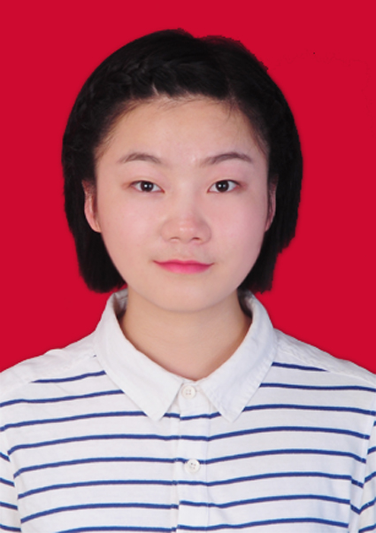
Gender | Female
Date of Birth | 1992.06.16
Location | Lhasa
Contact No | 18523118910
Address | Tashi Garden, Jiangsu east road, Lhasa
E-mail | 670895002@qq.com

Job Target
Target Industry | The health field
Target job | Program Assistant,The Tibet Health Capacity Building Program
Target address | Lhasa
Target salary | ￥5,000-6,000/Month

Working Experience
2014/10-2015/04
Industry: E-Business
Job content: Product Operation
2014/03-2014/10
Industry: Educational Training Center
Job content: Administrative Assistant

Education/Training
2010/09—2014/07 | Chongqing Medical University PSA Bachelor
2007/09—2010/07 | Shangqiu First Senior High School

Certificate
2014/07 | Certification of university graduated
2014/07 | Certification of Bachelor of Management
2013/03 | Certification of PETS
2012/11 | PSC
2011/06 CET4

Language skill
English: Fluent
Chinese:Fluent

Self-appraisal
Good sense of team work; strong ability in adapting to different environments Motivated and ready to learn at all times; ability to planning management; optimistic.
个 人 简 历

个人基本情况
求职意向：项目助理
姓 名：陈雪皎 性别：女
出生年月：1992.06 户籍：河南商丘
民族：汉 政治面貌：团员
毕业院校：重庆医科大学 专业：公共事业管理（医事法律方向）
学历：大学本科 学位：管理学学士
语言：大学英语四级、应用口语二级、普通话一级乙等
联系电话：18523118910 Email：670895002@qq.com
个人爱好：阅读、体育运动、旅行
自我评价
- 工作认真负责，能够很快地接受新事物，敢于迎接挑战，具备较强的统筹管理能力，相信细节决定成败。
- 性格开朗，注重有效沟通，具有较强的协作意识以及组织沟通能力。
- 具备较强的持续学习能力，追求自我提升。
- 喜欢读书，多纪实文学、管理学、心理学以及哲学、法律类书籍，有较强的观察、思考能力。
- 力所能及地做一些帮助他人的事情，关注社会的发展动态，希望能够为社会更好的发展做有价值的事。
专业素养
- 具备管理学、法律专业以及营销的相关知识，能够有效统筹管理各方资源。
- 有良好的文案撰写能力
- 具有高效的执行力以及团队意识。
- 具有较强的数据分析能力。
工作经验
时间：2014.10—2015.4
公司名称：北京本来工坊科技有限公司
部门：华北商品部
职位：产品运营专员
时间：2014.3—2014.10
公司名称：重庆博文计算机培训学校渝北分校
职位：行政助理

