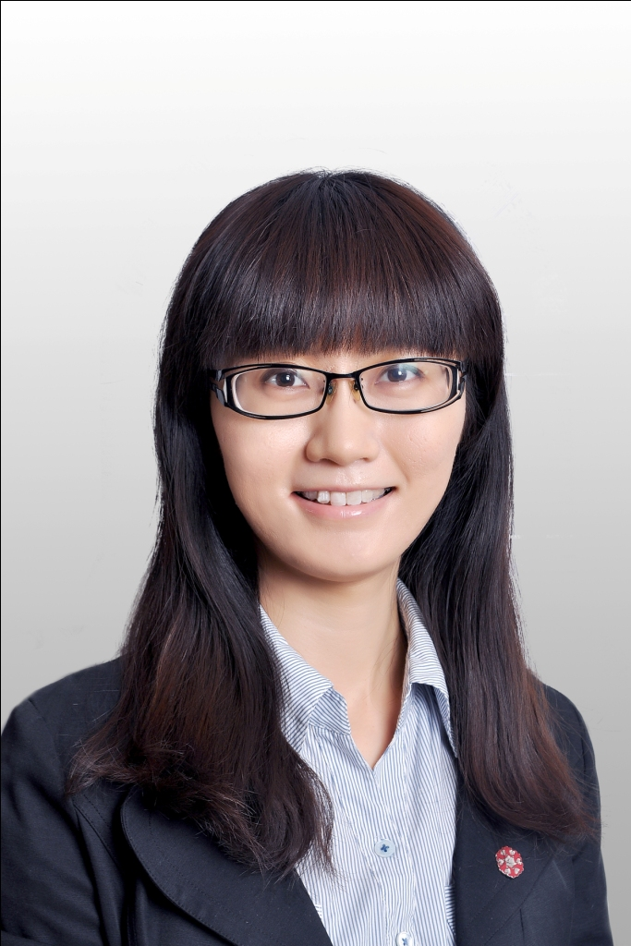
Hu Chaoyi
E-mail：huchaoyi_3232@hotmail.com Date of Birth: 08 Oct 1986
Tel：+86-159 0138 4779 WeChat: Huchaoyi_3232

Personal Statement
3+ years of project management experience on youth, poverty reduction and rural development (mainly Eagle Plan, 87 volunteers until now, experience working within government, universities, corporate, media and more than 20 NGOs.); experience working at both domestic and international organizations; communication and social media experience, with 6,000 subscribers for WeChat public account; Master of political economy and development from London School of Economics and part-time master of economics from Renmin University of China; seeking project management opportunities in international development field.
Work experience
07.2012- | Senior Program officer, YouChange Foundation Beijing
present | - YouChange is a leading Chinese private foundation focusing on poverty reduction and social innovation;  - [Project management] Responsible for coordinating youth & rural development programs, including the planning, implementing, monitoring & evaluating and communication of the following projects:  -Eagle plan: a year-long volunteer program sending young people to rural China for local community development; Youth Rural Service Program: funded by Agricultural Bank of China, sending Hong Kong university students to mainland villages for short-term community service; and China Survey: collaborated with South Reviews magazine, funding university students to conduct field research during summer holidays.  - [Training management]Responsible for the planning & budgeting, implementation and evaluation of capacity building trainings for volunteers, four times per year.  - [Disaster relief] Participate in Yunan Ludian Earthquake relief, helped with NGO working station building and relief supplies delivery and distribution.  - [International exchange and fund raising] Participate in the liaison of YouChange’s international partners (such as TOMS and GWPP); attend training on collective giving in the U.S. and the internal application of collective giving model in YouChange;  - [Administration] Responsible for all the program administration, including procurement (bidding and contract signing), consultancies, trip planning, knowledge management, etc.
11.2010- | Translator, International Committee of the Red Cross (ICRC) Beijing
07.2012 | - ICRC is an international humanitarian organization aiming at assisting victims of war.  - [Translation & interpretation]Translate and proof-read ICRC publications and other leaflets/brochures, film scripts, etc; translate more than 100,000 words; interpret during ICRC events, training courses and foreign experts’ outreach visits;  - [Administration] Filing, archiving, data management; budget and payment; contract signing and renewal.
Volunteer and internship

02.2014- | Founder & editor, Beijing Volunteer（Wechat:Beijing_volunteer） Beijing
present | - Beijing Volunteer is a WeChat public account dedicated to provide participatory and interesting volunteer information for people interested in philanthropy  - Founder and editor, responsible for content management and event organization, over 6000 followers up until now
05.2015 | Volunteer, Education Aid Myanmar
 | - Responsible for the local procurement and transportation of 10 tons of concrete to Je Yang Refugee Camp in Lazan, Kachin, Myanmar.
04.2009- | Intern, China Dialogue(http://www.chinadialogue.net ) London
08.2009 | - China Dialogue is the only bilingual environmental forum in the world, with branches in Beijing and San Francisco;  • Research on issues of environment in China; translate news, blogs; Advocate in social media, record video transcripts; Manage website; build database for interns and archive articles.
12.2008- | Volunteer Event Coordinator, British Red Cross Nottinghamshire Nottingham
07.2009 | - Coordinate fund-raising events such as walking, sky diving and ball; create posters and send invitation letters; coordinate fund-raising work shifts for more than 20 volunteers during National RC Appeal Week.  - Research and manage donor database; liaise with other volunteers;

Trainins
03.2015 | Program Evaluation Beijing
 | - Organized by WISPAD (Wilberforce International School for Poverty Reduction and Development), on various program evaluation methods, elementary calculus and cost-benefit analysis.
11.2014 | Project Management Beijing
 | - Organized by Peter·Drucker NPO Learning Center, a comprehensive training in program management.
04.2013- | Advancing philanthropy through collective giving (Training) Seattle
04.2013 | - A 10 days training session on collective giving model hosted by Washington Women’s Foundation. Participants include senior leaders of NGOs in Beijing and Shanghai., visited institutions including Gates Foundation, SVP, the United Way, etc.

Education
12.2012- | Master in Economics (part-time), Renmin University of China Beijing
09.2014 | - Modules include: micro- and macro-economics, econometrics, investment banking, policy analysis, political economy
10.2009- | MSc Political Economy of Late Development, London School of Economics London
09.2010 | - Modules include: theory, history and policy of development; urbanization and development;  Economic Development in East Asia; international trading systems; Graduate with merit.
09.2008 | BA International Business Administration, Nottingham Trent University Nottingham
09.2005 | English(E-commerce), Northeast Normal University Changchun
Language and IT
- Mandarin native speaker; Fluent in English. IELTS 7.5 (9 in Listening); Elementary German and French under training;
- China Accreditation Test for Translators and Interpreters (CATTI) English level 2 Translation Certificate (2011)
- Good command of Word , Excel, PowerPoint; Familiar with online social media; familiar with Photoshop and Corel VideoStudio
Translated work
- Vision and Calculation: Economics from a Chinese Perspective (ongoing). Collected works by Sheng Hong, Director of Unirule Institute of Economics.
- Water, international peace and security, Volume 2010, International Review of the Red Cross, pp 323-355, Beijing: Law Press China
- The Future of Afghanistan: the Afghanistan responsibility, Volume 2011, International Review of the Red Cross, pp 31-40, Beijing: ICRC

胡超逸
E-mail：huchaoyi@youcheng.org 出生日期：1986年10月8日
电话： +86-159 0138 4779 微信： huchaoyi_3232

个人陈述
3年以上青年志愿者与农村发展扶贫项目管理经验 （主负责小鹰计划，迄今培养出87名青年志愿者赴全国各地农村服务，并有与政府、媒体、企业及NGO合作经验）；熟悉国内及国际组织工作，曾在红十字国际委员会（ICRC）任翻译；新媒体运营者，公号粉丝超过6000；伦敦政治经济学院（LSE）发展学硕士、中国人民大学经济学在职研究生；对国际发展有浓厚兴趣，寻求国际发展领域的项目管理机会。
工作经历
2012.7 | 友成企业家扶贫基金会 高级项目官员 北京
至今 | - 友成基金会为国内领先非公募基金会，工作领域侧重于社会创新、人才培养与扶贫发展；  - 【项目管理】负责友成”小鹰计划”（青年发展项目，每年全国选拔20名青年赴各地乡村进行全职基层实践，负责招募、筛选、培训及学员支持）“乡村服务”（中国农业银行资助，组织香港青年赴内地重庆 、呼和浩特、云南等地五地乡村进行短期志愿服务）及“调研中国”（与《南风窗》合作，资助大学生团队进行社会实践和调研）三个项目的策划、实施、监测评估、传播等；共培养出87名小鹰学员，负责预算超过350万；  - 【招募与培训】负责项目推广及学员招募面试；负责设计、实施、评估培训及大型活动（每年4次）；  - 【国际合作与筹款】参与维护友成国际合作伙伴及项目（如TOMS和GWPP）；曾赴美国参加集体捐赠培训并将其引入友成；  - 【救灾】实地参与友成云南鲁甸救灾，协助在鲁甸县灾区搭建“源动力”工作站及救援物资发放工作；  - 【行政管理】负责项目行政相关事宜，如采购、招标、合同签署、顾问管理、出差管理、知识管理等。
2010.11 | 红十字国际委员会（ICRC）东亚代表处 翻译 北京
-2012.7 | - ICRC为国际人道组织，红十字红新月运动的发起者，旨在援助战争受害者和宣传国际人道法；  - 【翻译】翻译、校对ICRC出版物（中英文互译），在ICRC所办活动、培训班及外籍专家外出参观交流中提供口译及其他协助。  - 【行政】翻译项目协调及行政事务处理：翻译外包、翻译数据统计、合同签订、文件归档、财务等。
志愿及其他经历
2014.2 | 北京志愿服务资讯 (微信号：Beijing_volunteer) 创始人 北京
至今 | - 北京志愿服务资讯是一个微信公共平台，旨在为对公益感兴趣的人提供有趣、可参与的志愿服务信息；  - 负责平台的日常内容管理、对外联络及线下活动组织等，至今粉丝超过6000。
2015.5 | 教育援助队 志愿者 缅甸
 | 赴中缅边境克钦邦姐洋难民营，为当地学校采购运送10吨水泥并收集当地需求。
2010.4- | 中外对话 实习生 伦敦
2010.8 | - “中外对话”为世界唯一双语环保论坛，在北京和旧金山均有分部；  - 搜集有关中国环境、气候变化及CSR的资料；翻译英文新闻稿、博客评论及视频脚本；  - 协助网站日常管理与新媒体传播，建立实习生数据库和文章记录数据库。
2008.12- | 英国红十字会诺丁汉分会志愿活动协调员 诺丁汉
2009.7 | - 协助高级筹款经理统筹安排筹款活动；设计宣传海报并发送邀请信和劝募信（超过1000封）；  - 建立社区捐款者数据库；在红十字会筹款周时联络超过30名其他志愿者协调其工作。
培训及其他经历
2015.03 | 项目评估 北京
- 由WISPAD（Wilberforce International School of Poverty Alleviation and Development）组织
- 有关各类项目评估、统计学初级知识及投入产出分析（NPV）
2014.11 | 项目管理 北京
- 由彼得·德鲁克社会组织学习中心组织，讲师为世界宣明会学习与发展顾问
- 系统讲解项目设计、项目实施、项目监测及评估整理流程。
2013.4 | 以集体捐赠推动公益发展，华盛顿妇女基金会 西雅图
 | - 华盛顿妇女基金会是集体捐赠模式在美国的发起人，曾与南都、基金会中心网、映绿、恩派等机构代表一起赴西雅图学习集体捐赠模式，并将模式本土化在友成内部及小鹰计划项目内应用实践。
教育背景
2012.9- | 经济学硕士（在职），中国人民大学 北京
2014.9 | - 所学课程：宏观经济学、微观经济学、国际经济学、计量经济学、财政学、政治经济学等
2009.9- | 发展政治经济学(硕士)，伦敦政治经济学院 伦敦
2010.9 | - 所学课程：发展历史、理论与政策；城市化、人口与减贫；东亚经济发展史，WTO商业法；  - 毕业成绩2:1
2008.9 | 国际商务管理 （学士），英国诺丁汉伦特大学 诺丁汉
2005.9 | 英语电子商务（双学位学士），吉林省东北师范大学 长春
语言和计算机
雅思7.5（2007年，听力满分），英国留学两年，口语流利；全国翻译考试二级笔译证书（2011），多次从事笔译、口译工作
二外德语，工作后接受基本法语培训；国家普通话水平测试一级乙等 (2008)
全国计算机二级证书（2006），熟练掌握Excel/Word/PowerPoint；熟悉新媒体应用，Photoshop及会声会影
译著
《视野与计算：中国视角的经济学》，盛洪（现天则经济研究所所长）自选集，正在进行中
“水、国际和平与安全”，载《红十字国际评论》2010年卷，法律出版社2011年版，323-355页
“阿富汗的未来：阿富汗的责任”，载《红十字国际评论》2011年卷，红十字国际委员会2012年版, 31-40页

