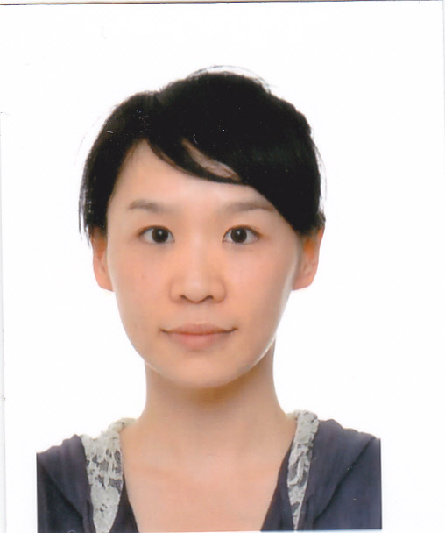
Gender: Female
Marital Status: Single
Date of Birth: 10th July, 1984
Place of Birth: Changsha, Hunan
Address: 20th Nanxincun, Xiangshan, Haidian, Beijing
Job Objective: Volunteer- Communication
EDUCATION
2014.9~Present Chinese Academy of Science
Enrolling doctor student in Key Laboratory of Plant Molecular Physiology，Institution of Botany
2006.9~2009.6 Central South University of Forestry and Technology
M.S. in Biochemistry and Molecular Biology
2002.9~2006.9 Central South University of Forestry and Technology
B.S. in Biotechnology
WOEKING EXPERIENCE
2011.8-2014.6 JIA DUO BAO Food & Beverage Group
Senior Engineer in Group Quality Administration Department
2009.9-2011.7 New Oriental Education & Technology Group
Director of Biology in Changsha New Oriental School
STANDARD TESTS
CET – 4 CET - 6 TOEIC-795 iBT-TOEFL-92

