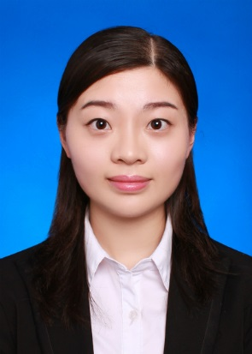
ZHANG Jiying

Room D137, District 2 of Taoyuan Dormitory, Jiulonghu Campus,
Southeast University，Jiangning District,
Nanjing, China, 211189

(+86) 1515-066-0230

290233224@qq.com

Objective  Education | To secure an entry in the FAO volunteer programme where my  skills and expertise are utilized in a way that helps both me and  the organization.  Bachelor of Philosophy, Graduation: June 2016  Major in Political Science and GPA: 3.9/4.0  Public Administration Average Score: 89/100  Southeast University  High School Affiliated to Nanjing Graduation: June 2012  Normal University

Experience  Award | Member of the Debate Club 2012.9. – 2013.6.  Member of the Southeast University 2012.9. – 2013.6.  Red Cross Organization  Exchange student to National Sun Yat-sen 2013.9. – 2014.2.  University, Taiwan  Editor of Students’ magazine “Southeast 2014.3. – 2014.9.  University Youth”  Member of the Summer Camp of University 2014.7.  Students' Entrepreneurship  Volunteer for Nanjing Youth Olympic Games 2014.8.  Journalist of School Newspaper 2014.9. to now  Award of Speech Competition  Course Excellence Award  Outstanding Officer of the Club  Jinsheng Reward Fund(Scholarship)  Third Prize in National English Contest for College Students

Skills | Good at English(IELTS 7.5)  Excellent practice skills; quick learner; good teamwork

Proficient in Microsoft Office Word, Excel and PowerPoint

Other interests including playing badminton, drawing and reading

