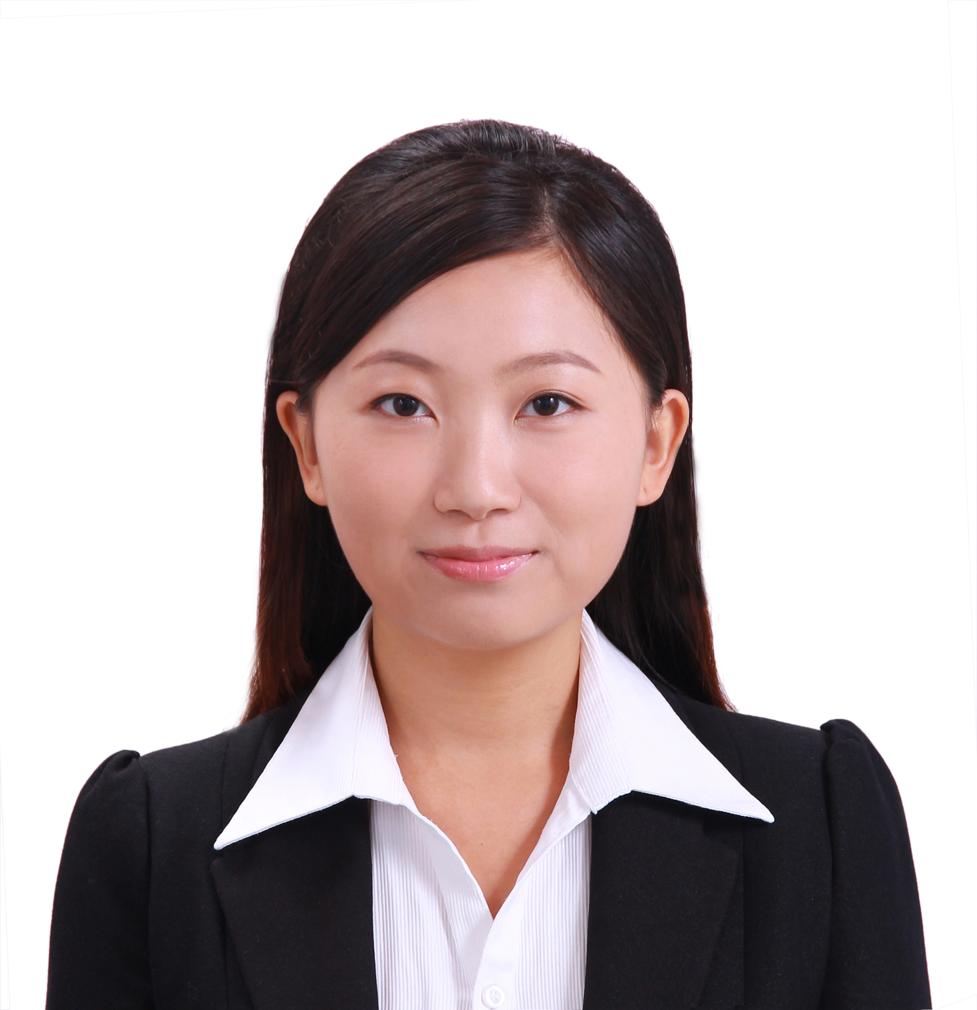
李 雪

手机：15120006607 邮箱：lixue6607@163.com
教育情况
中国人民大学经济学院,国际经济与贸易专业,经济学学士 GPA:3.43 2008.9-2012.6
首都师范大学文学院,中国古代文学,文学硕士 GPA:4.1 2012.9-2015.6毕业
基本技能
▪ 大学英语六级597,GRE 1540,托福101,初级挪威语
▪ 中英文写作能力及表达能力出色,熟练Excel、Word、Ppt
工作经历
联合国教科文组织驻华代表处,北京,信息与传播实习生 2015.2-今
- 协助项目管理，翻译(包括笔译和口译)文件，校对项目书，调研资料，维护更新网站
欧盟中国商会(EUCCC), 北京，政府事务工作组助理实习生 2014.11-2015.2
- 翻译(包括笔译和口译)法规文件, 定期组织、记录会议, 修改意见稿，制作新闻月报；
- 搜集整合信息，协助商会举办活动
北欧之刊(The Nordic Page)英文杂志社,奥斯陆,实习生 2014.1-8
▪ 撰写并发表约50篇文章,设计3期杂志主题,采访并撰写主要文章
▪ 杂志社日常管理工作,协助管理青年人新闻媒体培训项目
北京福莱希乐国际传播咨询公司,北京,实习生 2013.1-7
▪负责客户微博运营,写作新闻稿,制作汇报ppt,支持团队
国家旅游杂志社,北京,实习生 2012.5-8
▪ 搜集旅游信息,制作简报,新旅游项目调研,支持团队
中国人民大学出版社,实习生 2012.3-5
▪ 整理信息,协助会务
搜狐体育频道,北京,兼职翻译 2011.1-3
▪ 翻译英文文章,撰写有关极限运动、运动时尚的文章
中国人民大学经济学院团委宣传部,北京,副部长 2009-2010
▪ 采访多位教授,撰写经济学院新闻,编辑学院院报院刊
海外学习经历
挪威奥斯陆大学学院,奥斯陆,交换生 2013.10-2014.8
▪ 完成跨文化交流课程,与欧洲同学一起完成小组任务,获优秀成绩
丹麦哥本哈根大学学院,哥本哈根,交换生 2013.8-9
▪ 完成课程,参与哥本哈根孔子学院中文教学活动
香港岭南大学,香港,交换生 2011.9-12
▪ 修读6门文化研究课程均获优异成绩
日本关西大学,大阪,交换生 2011.11
▪ 进行演讲展示等交流活动
中国青年发展项目,纽约,项目成员 2011.7-8
▪ 参加在哥伦比亚大学举办的中国青年发展项目课程,撰写项目书，获结课证书
获奖情况
学习优秀奖学金,校级二等 2009
优秀班干部奖学金,校级二等、三等 2009&2010
中国人民大学优秀毕业生 2012
XUE LI (Sarah)
+86 15120006607
lixue6607@163.com
Education
Renmin University of China Sep.2008-Jun.2012
International Economics and Trade, Bachelor of Economics,GPA：3.43
Capital Normal University of China Sep.2012-Jun.2015
Chinese Ancient Literature, Master of Literature, GPA: 4.1
Skills
▪ Native speaker of Mandarin, fluent English and entry-level Norwegian
▪ TOEFL 101; CET 6 597; GRE 1540
▪ Use computer skillfully, proficient with office software, like Excel, PowerPoint, Word
Professional Experience
UNESCO Beijing Office, Communication and Information Assistant (Intern) Feb.2015~present
- Provide support to project and event management; Proofread publications translated from English;
- Conduct research; Translate various documents from Chinese to English and vice-versa;
▪ Assist in updating and maintaining the office website.
European Chamber of Commerce in China(EUCCC), Beijing, Government Affairs Working Group Assistant (Intern) Nov.2014-Feb.2015
▪ Conduct research on government affairs, gather comments from members and revise them for submitting to government;
▪ Translate regulations and other documents from Chinese into English and vice-versa;
▪ Organize meetings regularly, interpret for members at meeting, write meeting minutes in English;
▪ Assist the chamber in project and event like Annual Conference.
NorSensus Media& Syndication(The Nordic Page), an English magazine, Oslo, Intern
- Wrote around 50 articles on Norwegian news Jan.2014-Aug.2014
▪ Offered new ideas to the team on magazines, Managerial work for daily work and project
Fleishman Hillard Company, Beijing, Intern Jan.2013-Jul.2013
▪ Supported team in client service, like operating Sina Weibo Account and writing articles
China National Travel, a national magazine press, Beijing, Intern May.2012-Aug.2012
▪ Collected travel data efficiently, made news report, supported team
▪ Made research on new travel campaigns, updated magazine’s Sina Weibo Account
Sports Channel of Sohu, Beijing, Part-time Editor Jan.2011-Mar.2011
▪ Translated English reports into Chinese smoothly and published on the internet
Overseas Study Experience
University College UCC, Copenhagen, Denmark, Exchange Student; Oslo and Akershus University College of Applied Sciences, Oslo, Norway, Exchange Student Aug. 2013-Aug.2014
▪ Performed excellently in presentations and essays in courses like Cross-cultural Communication
Lingnan -Kwansei Gakuin University Exchange Program, Japan, Member Nov.2011
▪ Impressed Japanese students by presenting powerful speeches
Lingnan University, Hong Kong, Exchange Student Sep. 2011-Dec.2011
▪ Created an interest in international culture studies by performing excellently in six relevant courses
China Young Development Program, New York, Member Jul.2011-Aug.2011
▪ Attended lectures on consulting and media in Columbia University, got a certification of training
Awards
2009 University's second Scholarship for excellent academic performance
2009、2010 University's second 、third Scholarship for Outstanding Class Representatives
2012 University’s Outstanding Graduates

