CURRICULUM VITAE
PERSONAL DATA
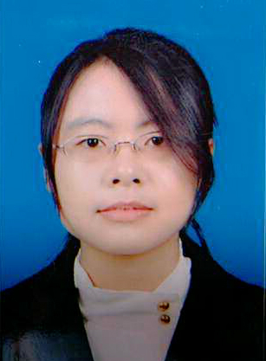
Name： LIU taoyu
Mobile: (0086) 13051297440
E-mail: liutaoyu1023@163.com

EDUCATION
09/2013- Master student in Ecology, University of Chinese Academy of Sciences(UCAS),Beijing
09/2009-06/2013 Bachelor student in Ecology, China Agriculture University(CAU), Beijing
(GPA: 3.73, Ranking:17/155, iBT:98 , Revised GRE: 317)
TRAINING
04-12/2013 CAU Ambassador Program Team 6
03-05/2013 Translation Training Course in Beijing Foreign Study University
12/2011 The Entrepreneurship Course Top U college (taught by Daniel R.Mulroy)
07-08/2011 Campus Elites Hongkong Finance Expanding & Training Program
awards
06/2013 Excellent graduation thesis of China Agriculture University
04/2013 The 17th FLTRP National English Debating Competition CAU Division Grade 2
10/2011-10/2012 National Aspiration Encouraging Scholarship;
Excellent Learning Scholarship Grade 2 with scholarship
04/2011 The 15th FLTRP National English Debating Competition CAU Division Grade 3
10/2010-10/2011 Excellent Learning Scholarship Grade 3 with scholarship
10/2009-10/2010 Jinzhengda Scholarship; Excellent Learning Scholarship Grade 2 with scholarship
working EXPERIENCEs
06--08/2013 Ecology Field Work in Inner Mongolia
08--09/2014 Ecology Field Work in Xinjiang Uygur Autonomous Region
06/09—13/09/2012 Ecology Field Work
26/08—04/09/2012 Resources and Environment Field Practice
20/07—20/08/2012 Field Study in Northwest China’s Ningxia Autonomous Region, Gansu Province and Shaanxi Province (Part of “The Integrated Survey Of Plant Community In North China”)
20/06—30/06/2012 Ecological engineer experiment at Huantai , Shandong Province
08/2011 Geology and Geomorphology Practice in mountains surrounding Beijing
SOCIAL ACTIVITIES
12/2014 Host of the New Year Celebration evening in the Institute of Botany
07/2014 Host of the singing contest in the Institute of Botany , Chinese Academy of Sciences
06/2014 Host of the Chinese Orchestra concert in UCAS
12/2013 Host of the New Year Celebration evening of UCAS
10/2013 Translator for The world’s elite education exhibition
06/2013 Host of the graduation party in China Agriculture University
10/2012 Judge of the First China British Parliament Debate Competition
10/2011-12/2011 Voluntary teacher in the Ming yuan School teaching migrant workers’ children
09/2011 Volunteer in the First Environmental Supervision Competition
10/2011 Volunteer at the Haidian Handicaped League
03/2011 Taking part in the debate tournament of the China Debate Academy held in Qinghuangdao
02/2011 Voluntary interpreter on bio-energy in Chinese Science and Technology Museum
(to explain the application of bio-energy to the public)

