简历
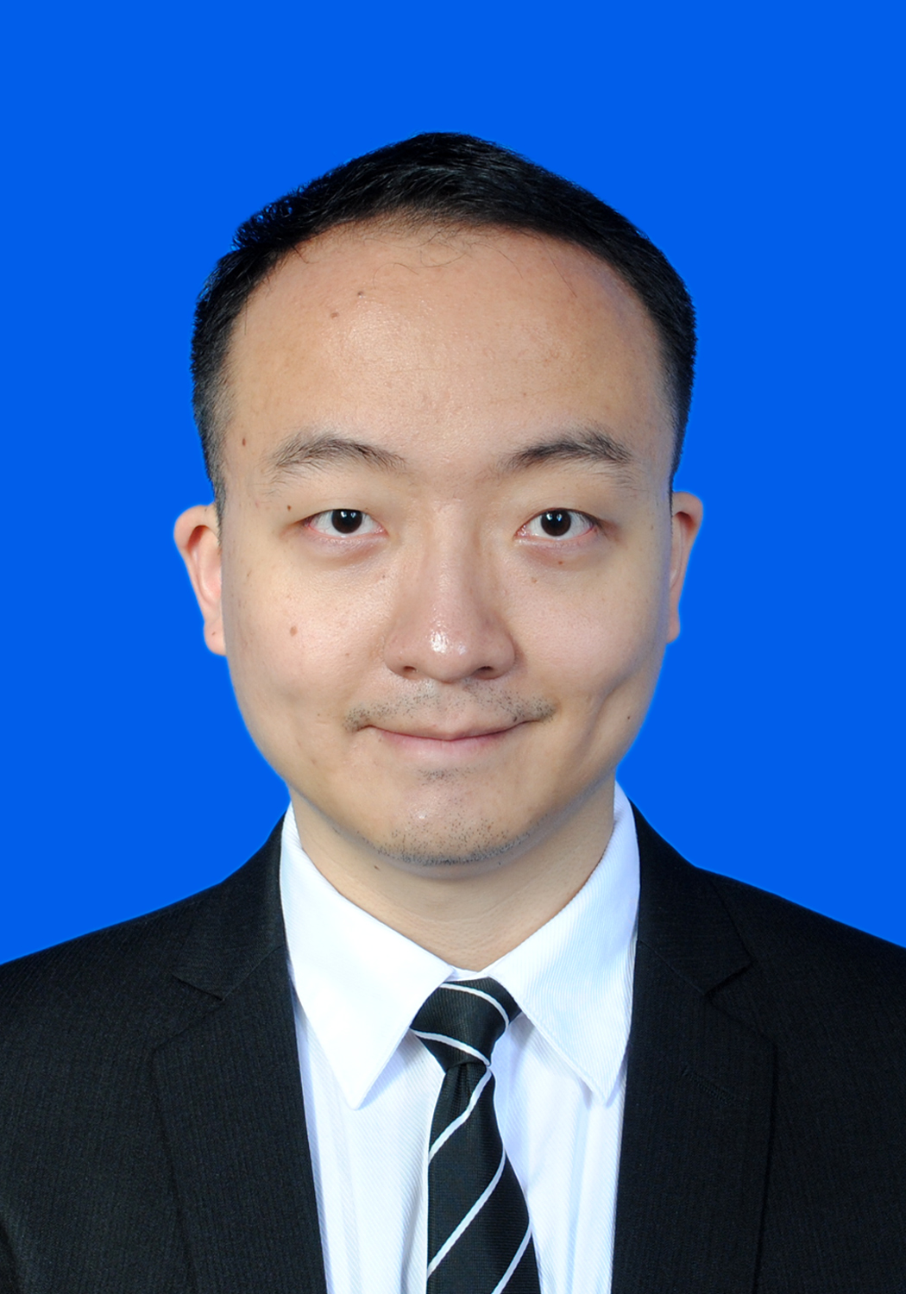
姓名: 彭继霆 性别：男 身高：180cm 体重：72 公斤
生日: 14/01/1986 手机：+86-18180920887 家庭座机：+86-28-85145765
身份证号码：510704198601149258 家庭手机：15881697191
E-mail: pengjiting@aliyun.com 籍贯：四川省绵阳市 户口：成都市
工作经历  03/2014 – 07/2014  08/2012 – 02/2014  12/2011- 07/2012  06/2010- 11/2011  06/2009 – 06/2010 | 渣打银行 | 管理培训生 | 上海、成都、重庆  个人银行客户经理:负责个人高净值客户理财销售（定岗工作级别得到提升）  商业银行管理培训生  18个月在几个不同核心业务部门轮岗,部门包括：1）中小企业银行-客户经理及华西区企业银行总监商务助理。2）风险审批。3）总部上海的全国性项目-财富管理产品部银保部门。4）个人银行-理财客户经理及市场活动经理。  IBM国际商业机器（中国），中国采购公司 | 全球采购工程师 | 深圳  等级：7. 主管级采购工程师，团队带头人-Team leader. 年度表现考核评定: 1(最高分)  等级：6. 服务器硬件采购工程师。供应商审计员资质,六西格玛精益绿带资质.年度表现考核评定: 2+。项目经历：2011/03-2011/12：精益六西格玛项目-IBM服务器硬件全球OEM供应商供应链改善及节省,该项目被评选为公司全球集成供应链年度明星精益项目，达到年度节省超过30万美金的开销节省  深圳新东方学校 | 基础教学部英语讲师  负责新概念英语1~4册的教学，结合创新教学模式进行授课, 学员打分最高以及最喜爱的老师之一。
教育背景  09/2007- 11/2008  09/2003- 07/2007  09/2005- 06/2006 | 香港科技大学| 机械工程（电子封装）| 理学硕士GPA: 3.6/4.0 排名前3%  南昌大学 | 材料科学与工程(金属) | 工学学士 GPA: 3.4/4.0 排名前8%  南昌大学 | 法律（律师与法学方向）| 辅修专业学位GPA: 3.3/4.0
在校获奖情况  06/2008  08/2007  07/2007  01/2007  10/2006  01/2005  05/2006 以及05/2007  10/2004 以及05/2005 | 香港科技大学独立研究课题A+  南昌大学“优秀本科毕业论文”, 3%  南昌大学“优秀毕业生”, 4%  2006年“昌大魅力人物”（全校投票选举10名）  三好学生标兵(南昌大学, 4%)  优秀学生干部（南昌大学，2%）  两次获得优秀学生特等奖学金(南昌大学, 前2-3%)  两次获得优秀学生一等奖学金(南昌大学, 前7%)
课外活动  05/2008  12/2006- 06/2007  04/2006  10/2003- 06/2004 | 奥运圣火香港传递期间“两岸三地优秀青年活动”学生大使  南昌大学3A俱乐部首任主席  《昌大学生》杂志第二期封面人物  南昌大学楼栋学生会副主席
比赛获奖  09/2008  10/2006  08/2005  06/2004 | 香港电台普通话DJ大赛“最佳才艺表现DJ”  第五届“挑战杯”飞利浦青年创业大赛国家级铜奖（团队获奖）  第六届全国大学生英语演讲赛国家级三等奖  2004年全国大学生英语竞赛国家级特等奖（国家级最高奖项）
电脑技能 | Windows, Office, Lotus Notes, AUTO CAD, C语言. Minitab, SPSS.
语言能力 | 母语为普通话,广东话中级，韩语基础，法语基础  英文-GMAT:650, GRE:1350, CET6：556, CET4: 97.
爱好 | 登山,羽毛球，网球，游泳，旅行，语言 等。

Name: PENG Jiting
Date of Birth: 14/01/1986 Gender: Male Height: 180cm Weight：72kg
Mobile: +86-18180920887 Home Phone: +86-28-85145765
Home town: Mianyang City, Sichuan Province, China Mobile 2: +86-15881697191
E-mail: pengjiting@aliyun.com ID No.: 510704198601149258 Location: Chengdu City
WORK EXPERIENCE  03/2014 -- 07/2014  08/2012 – 02/2014  12/2011 – 07/2012  06/2010 – 11/2011  06/2009 – 06/2010 | Standard Chartered Bank| Management Trainee, Relationship Manager  Relationship Manager for Distribution personal financial services  CBFT (Consumer bank Fast Track Management Trainee)  18 months extensive job practice in 4 business units including: 1) Retail Bank Distribution. Work as Customer Relationship Manager to get new customers to attract deposit and loan/mortgage, sell products like mutual funds, wealth management products, insurance. Seek new channels to sell to target customers. Do Micro-Marketing events with channels. 2) SME Banking (Small & Medium size Enterprise Banking). A) Enterprise Banking Relationship Manager. Develop relationship with SME customers through providing effective need based financial solutions such as lending and deposit products. B) Work as BPM-Business Planning Manager for the whole China west region covering 4 cities-Chengdu, Chongqing, Wuhan and Xi'An. Work as intelligence source of West region SME Head to provide data analysis and strategic advice support. 3) Credit Risk Approval Department for business approval (SME lending/loan product) and operation control.4) National project action for whole corporate in headquarter-Shanghai for Insurance Product Team collaborating with suppliers.  IBM China, China Procurement Company | Global Procurement Engineer  Band: 7. Staff Procurement Engineer. Team Leader. Performance: 1(Top performance, top 5% in the company)  Band: 6. Procurement Quality Engineer. Computer Hardware, Network equipment. PCBA Manufacturing facing for overseas OEM/ODM component suppliers. Certified Supplier Auditor. Lean Six Sigma Green Belt Certified. Performance: 2+ (just below top score 1, top 10% in the company) Work as Project Leader/Manager to have achieved 300K US Dollars cost-saving annually for “Global OEM supplier supply chain improvement”. Training and Career Program: Business and Financial Leadership; T-shaped cross functional Talented Business Leader program; DOX Lean Six Sigma Black Belt Trained. Project Management Basics. Certified Supplier Auditor.  New Oriental Education & Technology Group | English Language Teacher  Train students of different ages from Junior to senior level on English language basing on the book series-New Concept English. Create new study mode to cater the needs of students-oral study mode, overseas exams mode, domestic English language exams mode, etc. I was one of the most popular teachers with highest comment scores from students. Attracted new students to help double sales target.
EDUCATION  09/2007- 11/2008  09/2003- 07/2007  09/2005- 06/2006 | The Hong Kong University of Science and Technology| Mechanical Engineering (Electronic Packaging, eg. Chips and PCB boards) | Master of Science  Nanchang University| Materials Science & Engineering |Bachelor of Engineering  Nanchang University| Law | Minor degree  Ranking: First class of both postgraduate and undergraduate study  Postgraduate GPA: 3.6/4.0 Undergraduate GPA: 3.4/4.0
HONORS&AWARDS  06/2008  08/2007  07/2007  01/2007  10/2006  05/2006 and 05/2007  01/2005  10/2004 and 05/2005 | A+ (Top score) for my Independent Project of research of HKUST (3 out of over 50)  Excellent Graduation Thesis of Nanchang University (Top 3%),  Excellent Graduate of Nanchang University (Top 3%)  The Glamorous Person of Nanchang University in the year 2006(10 people in all)  Excellent Student of Nanchang University (Top 4%)  First Scholarship of Excellence (Top 7%- two times)  Outstanding Student Leader of Nanchang University (Top 2%)  Special(Top) Scholarship of Excellence (Top 3% – two times)
EXTRACURRICULAR  ACTIVITIES  05/2008  06/2007  12/2006- 06/2007  02/2006  10/2003- 06/2004 | Student Ambassador to the Beijing Olympic Torch relay related issue in Hong Kong  Member of the organizing committee of the International Workshop of “One-dimensional Nano-scale Materials” in Nanchang University  Founder and 1st President of 3A Club of Nanchang University  Cover Star of Campus Official Student Monthly Magazine (experience-sharing pages)  Vice Chairman of the Students’ Union of 5 schools of Nanchang University
COMPETITIONS  09/2008  10/2006  08/2005  06/2004 | The most talented DJ of “DJ Selection Competition of Radio TV of Hong Kong”  The Country Copper Medal Winner(Team) of the 5th “Challenging Cup ‘PHILIPS’ Entrepreneurship Competition” for Youth(National-level)  The Country 3rd Prize Winner of the 6th National English Speech Competition for China College Students(National-level)  The Country Special(Top) Prize winner in 2004 National English Contest for China College Students(National-level Top Prize)
LANGUAGE SKILLS | Putonghua/Mandarin, Cantonese Intermediate, Korean Basics, French Basics  English: GMAT, GRE, CET6. National Prizes. English Language Teacher Experience
COMPUTER SKILLS | Windows, Office, Lotus Notes, AUTO CAD, C Programing. Mini Tab, SPSS
HOBBIES | Badminton, tennis, hiking, swimming, watching movies, travelling, languages

