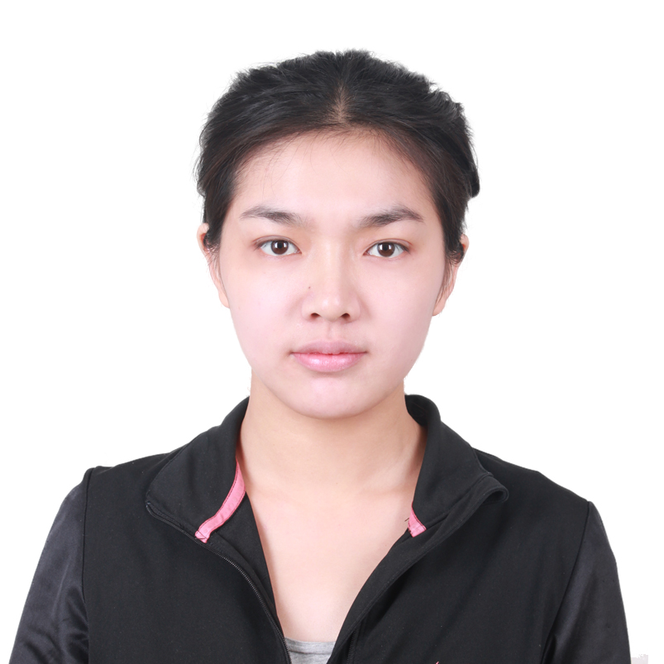
Miss Bai Qingyang
Rm102, Unit 2, Bldg 5, Shang’ao Shijizhongxin Xiaoqu，Xisanqi East Bridge, Haidian District, Beijing
EDUCATION BACKGROUND
University of Warwick 09/2013-09/2014
- Major: English Language Teaching (Studies and Methods) Degree: Master of Arts
University of International Business and Economics (UIBE) 09/2009-07/2013
- Major: International Politics Degree: Bachelor of Law
CAMPUS ACTIVITIES
Volunteer Organizer of the Opening Ceremony for Euro Exhibition in UIBE 02/2010-03/2010
- Cooperated with European Commission’s Delegation to China and organized the opening Ceremony;
- Received the Presidency of the Council of the European Union and the presidency of the EU;
Minister of Students Liaison Department of Bicycle Association 09/2009-06/2011
- Communicated with other outdoor sports organizations; Pulled the support for the Associations’ activities;
- Organized various Bicycle Competitive Sports and won the honor of Best Association in UIBE;
Leader of Academic Department of Student Union in School of International Relations 09/2009-06/2010
- Planned and hosted the various High-end Forum about international relations;
- Organized various quality development trainings for team members;
English School Manager of a private English Training Organization 10/2013-03/2013
- Communicated with Parents and foreign teachers; Acted as a TA during classes;
- Bought paper and other supplies for the school;
Assistant of the Investigation on The New Generation Migrant Workers launched by Scholar Liansi, who has written the famous book Yizu introducing low-income group with advanced degree 07/2012-08/2012
- Did field investigation to 6 migrant workers and drafted 4000-character interview report;
Assistant of the college scientific research project-Foreign Teachers’ Development Situation in China and Their Teaching Enthusiasm Investigation 11/2011-05/2012
- Obtained information from foreign teachers in universities through interviews and questionnaires survey;
- Recorded and Analyzed acquired data;
EXTRACURRICULAR ACTIVITIE
Volunteer Leader of Got Politics? Society 01/2014-03/2014
- Communicated with managers of British primary schools; Organized meetings before teaching;
- Taught British children basic political knowledge and theories;
English School Manager of a private English Training Organization 10/2013-03/2013
- Communicated with Parents and foreign teachers; Acted as a TA during classes;
- Bought paper and other supplies for the school;
Member of Bicycle Riding around Taiwan Island 08/10/2011-08/20/2011
- Attended the bicycle riding activity around Taiwan Island as one of the representatives of UIBE to celebrate 50th anniversary of Fu Jen Catholic University;
Researcher- Research on Mandarin Chinese Promotion in large international communities 07/2010-08/2010
- Investigated the promotion of mandarin Chinese in the Korean residential area in Wangjing Community, Chaoyang District, Beijing; Was highly praised by UIBE and rated as Key Team award, Brilliant Writing award and Outstanding Achievement award (Municipal level);
Volunteer Teacher of Beigao Experiment Primary School 09/2009 -12/2009
- Prepared lessons and teaching plan;
- Taught children English every Thursday and took them to visit universities after school;

VOLUNTEER EXPERIENCES
- Participated in voluntarily ecological forest tree-planting activity organized jointly by Beijing Mengtougou Journey of Hope organization and Alston China; 04/16/2011
- Took care of mentally disabled children in asylum of Huajiadi Nanli every Thursday; taught them pronunciation skills and solved their problems in daily learning; 03/2011-06/2011
- Attended volunteer Home-delivery teaching activity which was organized by Beijing Disabled Persons’ Federation for the disabled; 09/2010-11/2010
- Participated volunteer activity in “Life in Green City” World City Advocate Day in Chaoyang Park; 06/2010
SKILLS
- English: CET 6; Attended TOEFL and GRE tests; Lived in the UK for more than one year.
- Computer: Familiar with MS Office.

