Maksim S. Belov
Apt.602,1Fuguiyuan , Donghuashi St. ChongwenmenDistrict,Beijing,China●18618482856●belovmax@163.com

Business Translator, Managing & Consulting
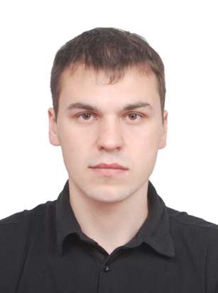
Dynamic and self-motivated businessman, committed to accurately representing his clients in International business communication during the organization and translation of negotiations. A trustworthy and accessible individual with excellent communication skills who is able to work comfortably with business partners of multiple national backgrounds individually or with a team.

PhD student at SIS International political major
Peking University (2013-Present)

Master of Education
Teaching Chinese Language
Qingdao University (2009-2011)

Chinese Language
Qingdao University (2008-2009)

Chinese Language
Institute for Far Eastern Studies
Borodich WF (2006-2008)

Administration
Thesis: The state and municipal government, the comparison of Russia and China
Russian State Service Academy (2002-2008)

English
Vladimir State Pedagogical University (2005-2006)

Work Experience
- 港 中 旅 国际 山东 旅行社—Translator (2009-Present)

Key responsibilities included meeting translation and accompanying client negotiation (commercial area).

- SHITUN, LTD—Translator (2007-2008)

Key responsibilities included sales organization and negotiation.

- Solo Consulting—Administrative Assistant (2007)

Key responsibilities included office organization, planning and scheduling meetings.

- Chinese Construction Firm—Translator (2005-2006)

Key responsibilities included meeting and document translation.

Languages: Russian—Native Speaker, Chinese—Master’s level, English—Conversational, Korean—Basic

