**超越国界——本土NGO倡导中国企业海外负责任投资研讨会邀请函**

**Beyond the Borders - Seminar on Advocation of Local NGOs for Responsible Overseas Investment by Chinese Enterprises**

**Letter of Invitation**

2014年以来，不论是金砖国家开发银行成立的推动，还是“一带一路”战略的提出，无不彰显出中国参与全球治理的决心。随着全球化进程的深入，国家的边界被弱化，世界正在以潜在的方式发生着联系。

China has been demonstrating its determination to become part of global governance in various activities since 2014, be it the establishment of BRICS Bank or the proposal of “One Belt And One Road” strategy. As globalization deepens , borders among nations become blurry, the world is showing potential interconnectedness.

在政府和市场的双重驱动下，中国企业也正积极“走出去”寻求更广阔的发展空间。然而，中国“政府搭台，企业唱戏”的对外发展战略，难以有效应对日益复杂的全球性公共问题，本土NGO参与全球治理的紧迫性日趋凸显。

Driven by the government and the market, Chinese enterprises are actively seeking after further development by “going out”. However, previous foreign development strategy that features the “government setting the stage and enterprises performing the show” fails to effectively deal with the increasingly complicated global problems, thus posing an urgent need for the engagement of local NGOs in global governance.

**本土NGO的契机**

**Opportunity for Local NGOs**

积极参与全球治理不仅是中国本土NGO应当履行的国际责任，也将有助于其获得更多生存和发展的空间。倡导中国企业海外负责任投资，涉及环境、劳工权益、社区发展、商业腐败等多方面问题，是本土NGO“走出去”的重要契机。

The active participation of global governance not only constitutes the duty of local Chinese NGOs in an international setting, but also contributes to their further survival and development. To promote responsible overseas investment by Chinese enterprises concerns multiple aspects such as the environment, labor rights, community development and business corruption, thus bringing forward an important opportunity for local NGOs to “go out”.

中国企业“走出去”不仅关系东道国的可持续发展，也与本国的社会问题息息相关。中国本土NGO倡导中国企业海外负责任投资，一来能够借助国际压力，为企业和政策倡导打开更大空间；二来可以联结国际社会，表达中国本土NGO的态度和主张，提高自身在全球治理体系中的话语权。

Chinese enterprises “going out” not only influences the sustainable development of host country, but is also closely related to various social issues of China. By promoting responsible overseas investment by Chinese enterprises, local NGOs in China could bring further room for enterprises and policy advocacy with the help of international pressure, as well as unite the international community to express its attitude and opinion, thus improving its international standing in the global governance system.

**本土NGO的准备**

**Preparation of Local NGOs**

本土NGO倡导中国企业海外负责任投资， 不仅需要具备全球视野来思考和解决本土问题，更要以全球公民的心态，来参与国际社会问题的讨论与解决。然而目前，相对于政府和企业，中国本土NGO“走出去”的步伐明显滞后，关注中国企业海外投资的机构也十分有限。

In order to promote responsible overseas investment by Chinese enterprises, it’s necessary for local NGOs to not only equip itself with an international perspective in considering and solving problems in local society, but also participate in the discussion and resolution of problems in the international community as a global citizen. However, it’s obvious that local Chinese NGOs “going out” are lagging behind compared with the government and enterprises, and there’re only limited institutions that focus on the overseas investment by Chinese enterprises.

鉴于上述现状，为了提高本土NGO对中国企业海外投资相关问题的关注度，并参与到倡导负责任投资的行动中，社会资源研究所（SRI）将于12月17日举办“超越国界——本土NGO倡导中国企业海外负责任投资研讨会”。

In view of above situation, the Social Resources Institute (SRI) plans to hold a seminar themed “Beyond the Borders - Seminar on Advocation of Local NGOs for Responsible Overseas Investment by Chinese Enterprises”, in the hope of enhancing the focus of local NGOs on issues relevant to overseas investment by Chinese enterprises, and encouraging their participation in promoting responsible investment.

会议将邀请国内外非政府组织，共同探讨中国本土NGO倡导中国企业海外负责任投资的价值和意义，并探索有效的倡导之道。

NGOs home and abroad will be invited in the conference to jointly discuss the value and meaning of promoting responsible overseas investment by Chinese enterprises through local NGOs in China, and explore an effective way for implementation.

**会议安排**

**Conference Arrangement**

**时 间：**12月17日 9:00-17:00

Time: Dec.17 9:00-17:00

**地 点：**鸿芷咖啡厅•北京市东城区南竹竿胡同2号银河SOHO A座10320

Location:

Hongzhi Café, No.10320, Yinhe Building A, No.2 South Bamboo Alley, Dongcheng District, Beijing

**语 言：**中文，英文同声传译

Language: Chinese, with simultaneous English interpretation

**议 程（暂定）**

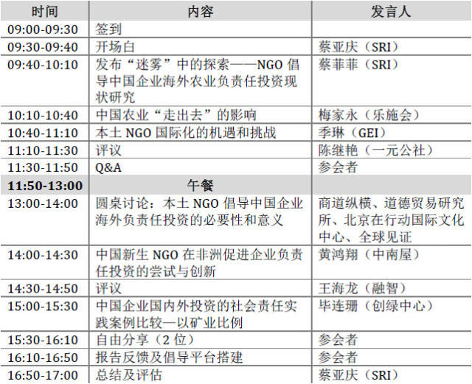

**Agenda (temporary)**

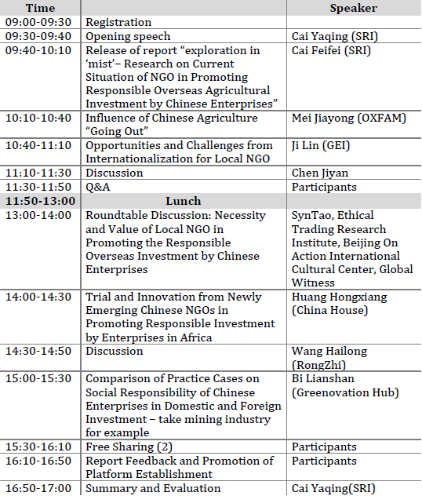

我们诚挚邀请您参加此次研讨会。报名截止日期：12月16日上午12点，报名请点击：<http://www.diaochapai.com/survey/5ba6bf3d-9a5d-4b3f-bf6b-b923a7aa4733#rd>

我们会预留2个自由分享机会，邀请参会者进行10-20分钟的主题演讲，欢迎报名。

We sincerely invite you to attend this seminar. Registration deadline: Oct.16 12am.Click on：<http://www.diaochapai.com/survey/5ba6bf3d-9a5d-4b3f-bf6b-b923a7aa4733#rd>

we’ll invite two guests to give a keynote speech for 10-20 minutes in the free sharing part. Your registration is warmly welcomed.

**联系人：**蔡菲菲/Contact: Cai Feifei

**电 话：**15210552428/Tel.: 15210552428

**邮 箱：**ff.cai@srichina.org/Email: ff.cai@srichina.org

**社会资源研究所**

社会资源研究所（Social Resources Institute，SRI），创立于2008年，是一家非营利性的研究与咨询机构。我们通过研究社会问题的成因及有效解决方案，评估社会性项目的策略和成效，生产及推广知识产品等工作方式，推动社会变革的产生。目前，SRI设有农业与发展研究中心和有效公益研究中心，与非营利组织、企业和政府合作，共同构建一个公正、自由和参与的社会。

**Social Resources Institute**

The Social Resources Institute, being a non-profit research and consulting institute that is established in 2008, aims to promote social reform by studying the cause of social problems and effective solutions to these problems, evaluating the strategy and effectiveness of social programs, producing and popularizing intellectual products. Currently it consists of agricultural and development research center and effective philanthropy research center, and works with non-profit organizations、enterprises and the government to jointly build a society that promotes justice, freedom and participations.

**乐施会**

全球每三个人之中就有一个贫穷。乐施会推动民众力量，以消除贫穷。

乐施会在世界各地以务实及创新的方法，协助贫穷人改善生活及持续发展。我们积极回应人道危机，提供救援，并协助恢复生计。我们推行公众教育及倡议运动，协助贫穷人发声，以改善本土及全球的扶贫政策。

乐施会与贫穷人及伙伴携手，消除贫穷以及导致贫穷的不公义情况。

**Oxfam**

One person in three in the world lives in poverty. Oxfam is determined to change that world by mobilizing the power of people against poverty.

Around the globe, Oxfam works to find practical, innovative ways for people to lift themselves out of poverty and thrive. We save lives and help rebuild livelihoods when crisis strikes. And we campaign so that the voices of the poor influence the local and global decisions that affect them.

In all we do, Oxfam works with partner organizations and alongside vulnerable women and men to end the injustices that cause poverty.