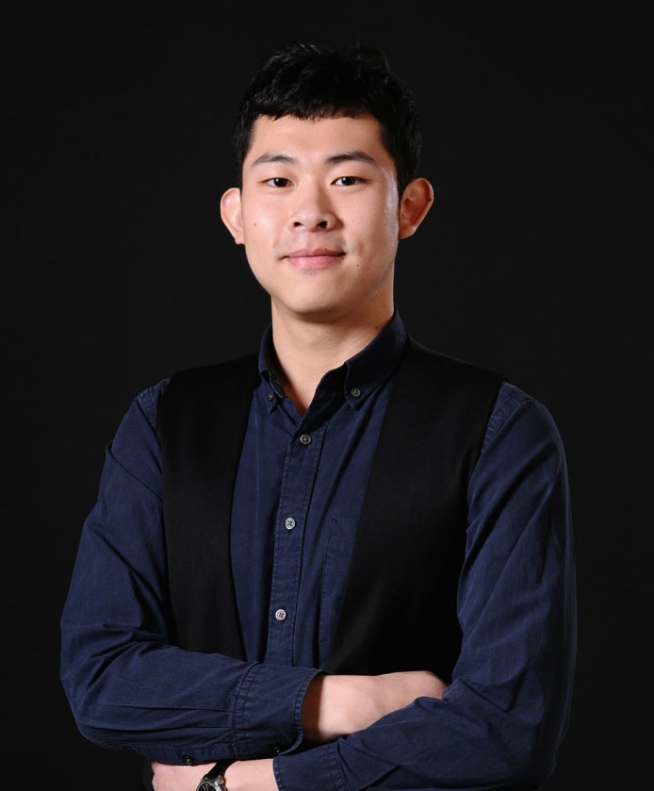
Curriculum Vitae

Basic Information：

Name：YANG Chao
Date of Birth：August 23, 1987
Tel：15210821762
Email：ninjavince@163.com

Education Background：

09/2010-09/2011 The University of Leeds UK Master Degree
09/2006-06/2010 The Ocean University of China Bachelor Degree

Working Experience：

03/2014-present CCTV News Producer
- Attending daily/weekly meeting, gathering news pitch from domestic agenda as well as international agenda.
- Delivering information to the producer team.
- Offering technical support to the live broadcasting.

02/2013-12/2013 Aoji Education Group Business Supervisor
- Responsible for the regional manager, fulfilled team and personal sales target,
- Trained new employees.
02/2012-02/2013 Aoji Education Group Consultant
- Offered consultant service to clients and made personal development strategies for them.
- Communicated with other teams in headquarter as well as branches overseas.

University Activities:

2012 Shanxi Broadcasting Center, Intern Producer
2011 Leeds Festival, Photographer
2011 Leeds Pride, Photographer
2010 The 2nd International Percussion Competition China, Volunteer
2010 CCTV News Center, Intern Reporter
2009 Chester Food Ltd. USA, Internship
2008 Beijing Olympic Games, Volunteer
2007 The 1st International Violin Competition China, Volunteer

